one.

do you know what to expect

when tomorrow arrives?

JJ1

witness the unexpected july 15-22

at baltimore convention center.

(Z

u

c:

o

4-J

ro

E

i_

o

M—

£

£

o

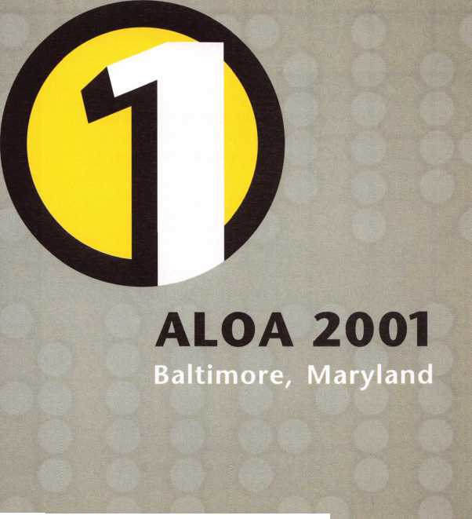

Features

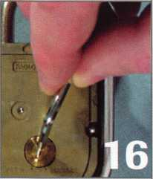

**25**

k. /r, . .

President’s Journey

13

W-LOK’s “Padlock for the Ages”

By Diane Broekhuis

14

“It’s Just a Padlock...”

Company insider Billy Edwards explains the features of Masters ProSeries locks — designed for specific use by locksmiths. You might be surprised what you find inside.

By Billy B. Edwards Jr., CML

Cover: The Exotic Padlock

S&G has a series of high security padlocks you may have never come across. But thousands are sold inter­nationally to government agencies each year. Here’s how you can save face when this rare and tricky crea­ture sneaks across your path.

By Brian Costley, CML, CMST

25

ABUS S3 Series Locks:

Variety on the Commercial Side Find out the latest features and servicing tips for the series 83 commercial padlocks from ABUS. Includes an explanation of IC core features, as well as the series 83/55 “rekeyable diskus.”

By Sal Dulcamara, CML

28

Remembering Russ Waller

Government security giant and long-time ALOA activist Russ Waller passed away recently. Here’s to remembering a man who quietly worked wonders for locksmithing.

By David J. Killip, CML

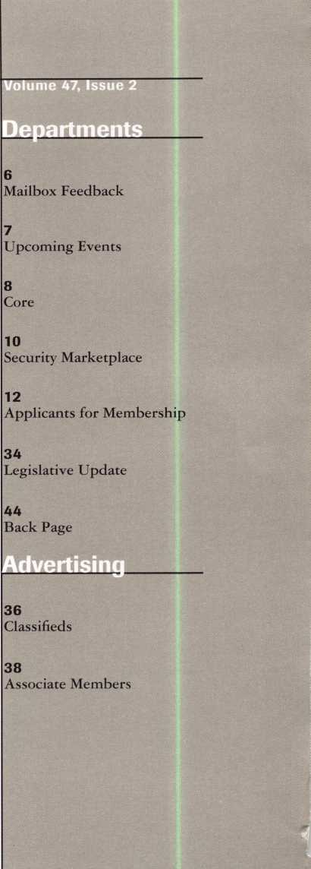

30

Introducing Selling Price

Ever get that uneasy feeling when it’s time to talk numbers with your prospective customers? Focusing and getting your ducks in a row before your sales pitch can make all the difference in the world.

By Claire Cohen, CML

Art direction/design Phoenix Design **972.479.9026** ConQuest Graphixs **817.285.0003**

32

Smart Strategies

Need some fresh ideas, or a new primer on how you can cut down on business borrowing and leverage your customer base more efficiently? Check out this easy-to-follow overview of current business strategy.

By David W. Tralka



Keynotes

February 2001

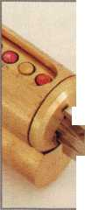

**Master ProSeries  
ABUS Series 83**

**• W-Lok**

**SSG Model 8077**



Like a Swiss army knife, once you open it up, you'll never let it ao.

st*attec

Leadln9 the Industry Si„ce *j914*

The new STRAT-A-Various™ from STRATTEC: All those little parts you always need for pinning locks on late-model Chrysler, Ford, GM, and Mitsubishi vehicles. All the tumblers, all the springs, all the spring retainers. All in one neat little kit. All you have to do is give your STRATTEC distributor a call. Then open your new STRAT-A-Various, and enjoy the convenience.

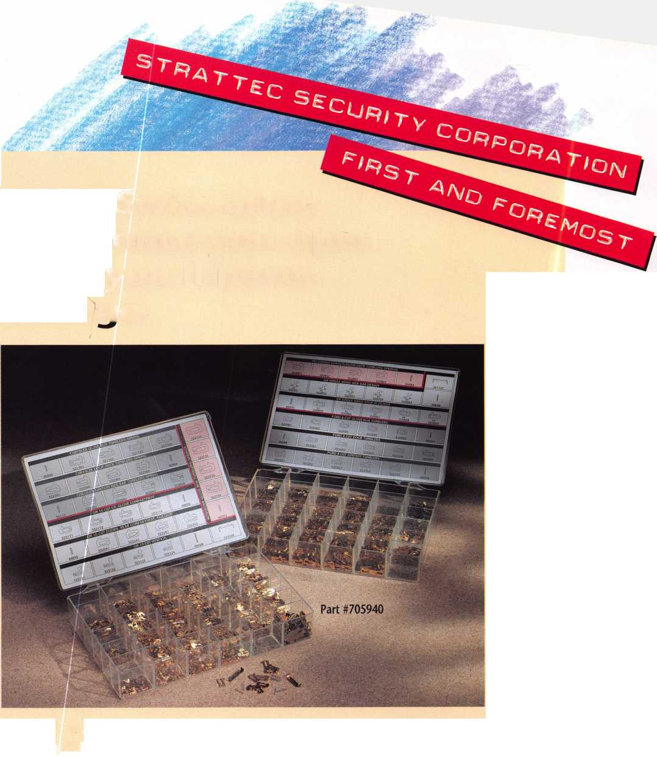

|  |  |
| --- | --- |
| Technical Editor | David Lowell, CML, CMST [david@aloa.org](mailto:david@aloa.org) |
| Editor | Patanya Johnson [editor@aloa.org](mailto:editor@aloa.org) |
| Editorial Advisor | John D. Cannon, CML [jdcannon@worldnet.att.net](mailto:jdcannon@worldnet.att.net) |
| Advertising Sales | Marvin Diamond  Native American Journal Co. (770) 993-3544 thediamonds @mindspring .com |
| Contributing Editors | Paul Chandler, CRL  Claire Cohen, CML  Sal Dulcamaro, CML |
| Contributing Authors | Jerome V. Andrews, CML  Brian Costley, CML, CMST  Bob De Weese, CPL  Ray D’Adamo, CML  Michael A. Ferrill  James Glazier, CML  Daniel Graffeo, CRL, CMST Wayne Gurnee, CRL  A.J. Hoffman, CML  Ken Holmlund, CRL  Ray Lusk, CML  Mark Ohno  Randy Simpson, CML  Robert Stafford, CPL  Dave Thielen, CML |
| Executive Director | Charles W. Gibson, Jr., CAE [charlie@aloa.org](mailto:charlie@aloa.org) |
| PRP/Education Manager | David Lowell, CML, CMST [david@aloa.org](mailto:david@aloa.org) |
| Operations/Membership Manager | Mary May [mary@aloa.org](mailto:mary@aloa.org) |

Executive

3oard



Additional contact information for the ALOA Board and most Keynotes authors is available through “Locksmith Search”' on the ALOA Web site- [www.aloa.org](http://www.aloa.org) or by contacting the ALOA office at 3003 Live Oak Street; Dallas, TX 75204; 0800J532-2562;

FAX [214)827-1810; e-mail [aloa@aloa.org](mailto:aloa@aloa.org).

President

John J. Greenan, CML, CPS (773J 486-2030 [fsl.john@mindsphng.com](mailto:fsl.john@mindsphng.com)

Secretary

John D. Cannon, CML (703) 960-6413 [jdcannon@worldnet.att.net](mailto:jdcannon@worldnet.att.net)

Directors, Northeast

John C. Magee, III (8563 845-3434 Peter Sarailian, CRL (2013 947-6291 [psarailian@yahoo.com](mailto:psarailian@yahoo.com) William L. Young, CML (6103 647-5042

Directors, Southeast

Thomas W. Tate (8503 476-4211 Donald E. Rule, CML (6013 324-2658 [rulecml@ebicom.net](mailto:rulecml@ebicom.net)

Directors, North Central

Mark E. Blum, CML, CPS (5173 482-5809 [mblum@arq.net](mailto:mblum@arq.net) Tom Ripp, CRL (6083 262-3831

Director, South Central

Randy L. Simpson, CML (7133 780-7026

|  |  |
| --- | --- |
| Information Systems Manager | Randy McChristian |
| Government Affairs Manager/ Chapters & Regional Associations Liaison | Tim McMullen [tim@aloa.org](mailto:tim@aloa.org) |
| Comptroller | Kathy J. Romo |
| Network Specialist | Greg Jackson |
| Membership Coordinator | Shelly Jett |
| PRP/Education Coordinator | Ashley Manson |
| Accounting Coordinator | Kathy Stokes |
| Meeting Coordinator | Thom Terry |
| Mail Room Coordinator | Emmett McCrohan |
| Receptionist | Alin Valdez |



ission Statement: The Associated Locksmiths of America, Inc. is dedicated to enhancing the professionalism, education and ethics among locksmiths and lose in related sectors of the physical security industry. With approximately 10,000 members in the United States, Canada and the freeworld, ALOA is poised to elp members obtain the knowledge, the strength, and the confidence to perform their role in the physical security field with pride and dignity. But it is only trough active involvement and participation that ALOA can fully achieve its potential-and can help members to achieve theirs.

'olicies: Keynoted is the official publication of the Associated Locksmiths of America, Inc. (ALOA3. Keynotes® acts as a moderator without approving, isapproving, or guaranteeing the validity or accuracy of any data, claim, or opinion appearing under a byline or obtained or quoted from an acknowledged Durce. The opinions expressed by the authors do not necessarily reflect the official views of ALOA. Also, appearance of advertisements and new products or srvice information does not constitute an endorsement of products or services featured by the Association. The Association does not accept responsibility for le inaccuracy of any data, claim, or opinion appearing in this publication, due to typographical errors on the part of the authors, Association staff or its agents, ditor’s Note: This publication is designed to provide accurate and authoritative information in regard to the subject matter covered. It is provided and isseminated with the understanding that the publisher is not engaged in rendering legal or other professional services. If legal advice and other expert ssistance is required, the services of a competent professional should be sought.

LUthors’ Payment: Payment for eligible submissions to Keynotes will be based on the following criteria: topic, time spent and past contributions. Authors who jgularly submit to Keynotes are generally paid a higher rate. The latter is especially true of authors who write to fit specific editorial needs and submit said copy y Keynotes deadlines. As a general guideline: Average payment for a 750 word, business or ‘light’ technical article would be $200. Payment for a 1500 word article ivolving significantly higher time and research efforts would be $400.

Payment will not be offered for articles submitted by ALOA employees or members of the ALOA Board of Directors (unless material is of a technical nature], or for articles submitted by a company that promote that company’s products or services. ALOA reserves the right not to pay for articles submitted by an idividual(s] that promote a particular company’s products or services.

)isclaimer: The Associated Locksmiths of America, Inc., (ALOA], reserves the right to refuse any article for any reason. Additionally, ALOA reserves the right ) edit, amend or modify any article submitted for publication in order to preserve technical accuracy, clarity, fairness or grammatical correctness. ALOA will make le best efforts to notify the author of any changes. The extent of ALOA’s liability for any article or information contained therein will be a notice of correction or fraction in the next possible issue.

eynotef’ (ISSN 0277 0792) is published monthly except for the combined June/July issue by The Associated Locksmiths of America, Inc., 3003 Live Oak St., (alias, TX 75204-6186. Telephone: (214) 827-1701; FAX (214) 827-1810; e-mail [aloa@aloa.org](mailto:aloa@aloa.org). Subscription rates for members-$15.00 per year. Second class ostage paid at Dallas, Texas. POSTMASTER: Send address changes to; Keynotes, 3003 Live Oak St., Dallas, TX 75204-6186. © Copyright 1999, All rights ^served. No part of the contents may be reproduced or reprinted in any form without prior written permission of the publisher.

Directorsy Southwest

Gordon R. Racine, CML (719) 384-4707 [aloaswdir@excite.com](mailto:aloaswdir@excite.com) John A. Ilk, CRL (6023 420-2174 [getreil@yahoo.com](mailto:getreil@yahoo.com)

Director, Northwest

Scott L. Henke, CRL, CPS (9073 248-3785 [action@alaska.net](mailto:action@alaska.net)

Director, Associate Members

David F. Matthies

(7273 541-5536

[dmatthies@southernlock.com](mailto:dmatthies@southernlock.com)

Trustees

Dallas Brooks

(3343 826-8990

David M. Lowell, CML, CMST

(8003 532-2562

Breck H. Camp, CML

(7703 455-6244

Edwin Toepfer, RL

(4163 225-5589

Past Presidents

1997-1999 Dallas C. Brooks

1995-1997 David Lowell, CML, CMST 1993-1995 Breck Camp, CML

1991-1993 Henry Printz, CML

1989-1991 Evelyn Wersonick, CML, CPS

1987-1989 Leonard Passarello, CPL

1985-1987 Joe Jackman, CML

1983-1985 Stanley Haney, CPL

1981-1983 Louis LaGreco, CPL

1979-1981 John Kerr, RL

1977-1979 Clifford Cox, CML

1974-1977 Charles Hetherington

1972-1974 Gene Laughridge

1970-1972 William Dutcher, RL .

1968-1970 Constant Maffey, RL

1966-1968 Harold Edelstein, RL

1964-1966 William Meacham

1962-1964 Robert Rackliffe, CPL

1960-1962 Edwin Toepfer, RL

1956-1960 Ernest Johannesen

***Keynotes***



February 2001



Keynotes

February 2001

_

ALOA constantly strives to bring new services to its members by providing them with the tools they need to advance their careers in this fast moving, ever changing profession.

ALOA continues its excellence in educational programming by offering more than 150 ACE certified classes this year as well as over 35 PRP sittings. The PRP continues to bring more sittings to more locations so that members won't have to travel as far or wait as long to achieve their certifications. ALOA also provides the opportunity to take a PRP elective right after a PRP certified class. ACE also has compiled a library of reference material so that members can get their study materials from one source. Soon there will be an on-line bookstore where members can purchase these references. The ALOA Education Department is working with more local associations and sponsors to bring classes with ACE certified instructors into areas closer to you throughout the year. Don't forget that there are reduced member rates for the PRP and ACE classes. Members can also take the PRP exam the second Friday of every month at the ALOA headquarters in Dallas, Texas.

On the legislative front, ALOA has already been working hard for members, identifying bills that were pre-filed or introduced which affect our industry.

In Illinois, a bill was introduced that provides for tow-truck operators to perform locksmith services without a license as long as they don't use the word "locksmith" in their advertisements (but still advertise that they unlock cars!). Needless to say, we are fighting this bill on behalf of ALOA members. There are also alarm bills in Mississippi and Ohio that we are keeping our eye on. ALOA members can participate in the Legislative Action Network, which allows you to have the latest news regarding legislation that may affect your profession. You can now even find out who your legislator is Online!

If you just got a new computer for Christmas (or haven't been Online for awhile), check out the improved ALOA Web site. We offer members free subscription to the Internet Security Reference which includes the Magazine Cross Reference, Space and Depth Database, Miscellaneous Codes (Padlock and Furniture), Small Format Interchangeable Core Utilities, Keyblank Cross Reference, Security Manufacturer Database and Master Key Plus. One of the most valuable benefits of membership is the Locksmith Referral program that we offer the general public. As a member, your name and phone number will be given to potential customers who either call the ALOA headquarters or look us up on the Web. The ALOA Web site also provides members instant access to scholarship applications and convention registration.

ALOA members also can participate in the upcoming Safe and Vault Technicians Association (SAVTA) 2001 International Convention, SAFETECH 2001: "A Safe Odyssey". This year's event will be held in St. Louis, Missouri, April 30 - May 5. The convention is open to all ALOA members and includes six-days of educational classes and seminars to help you keep up-to-date with the latest technology in the safe and vault industry. There is also a large trade show with over 40 manufacturers and distributors exhibiting the latest in security products.

Of course, the ALOA Annual Convention and Security Expo to be held in Baltimore, Maryland, July 15-22, is the premier event of the year for locksmiths.

As a member, you'll receive the convention brochure before anyone else, and be able to sign up for popular classes before they are full!

If you look at the cover of this issue of the magazine, you will notice our new tag line: ALOA - An International Association of Security Professionals. This new phrase pretty much sums up what we are: security professionals.

Sincerely,

John J. Greenan, CML, CPS

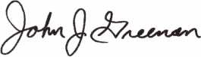

***Visit our Website on  
www. stamcctv. com***

THE COMPLETE

CCTV PROGRAM ON CD-ROM  
FOR STAFF TRAINING AND

PRODUCTIVITY ENHANCEMENT

STAM Insight has been

developed to enhance CCTV  
skills and productivity with  
many different uses.

St Productivity

Of System Drawing Of Estimation t# CCTV Training St CCTV Reference S# Sales/Demo System Design Staff Evaluation

**INFOMATE WORKMATE ULTIMATE**

|  |  |  |  |
| --- | --- | --- | --- |
| r CCTV Content | 10 tours |  | 10 tours |
| CCTV Calculators | / | m  „ L , | / |
| ( Demonstration Tool |  |  | ' t |

14 tour*

—1

i!

Estimation

Drawing

Internet Enabled

Pre-Test

Quizzes

Knowledge Assessment

4H

*m* I *Mo* p

r

NO No

r

**No Mo**

**Sold in Over 50 Countries**



Distributed by:

3003 Live Oak Street  
Dallas,Texas 75204

COPYRIGHT © 1996 Security Training and Marketing Pty Ltd. All rights reserved ACN 057 006 541

■ Yes, please send me a FREE PREVIEW CD ROM $9.95 S/H

Name:

Job Title:

Organization:

Address:

Zip/Postcode

Country e-mail

Tel: ( ) Fax: ( )

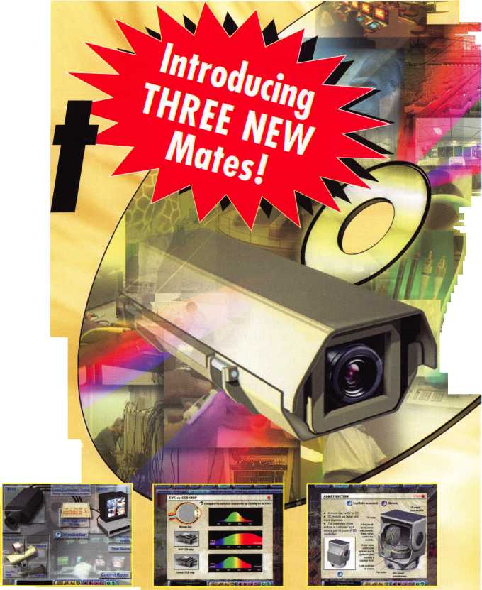

ailbox

Feedback

Dear Editor,

In response to the article “Where have all the Mentors Gone?” (volume 46, issue 11) I would like to submit this tidbit.

Having spent over 18 years in the US Army, being bumped all over this world and having these difficulties cost me several marriages, I had to find a way to subsidize my income. In 1986 after my first divorce while stationed in Germany, I signed up and started the NRI correspondence course for Locksmithing.

I knew with the first lesson that this was for me, I dug into every lesson, spending as much time as I could to developing skills in this field. Since time and space where a commodity, I had to travel light. So armed with a basic pick set and a leatherman, I began to practice on the only readily available locks there were - the American US issue 5200 series padlocks and BKS profile cylinders commonly found in almost every German Kaserne.

Over the next several years (1986-1991) I practiced daily, thinking I really knew something and having become pretty good with pinning and picking.

In 1994 having survived the cold war and desert storm, I was stationed at Ft. Knox. What an opportunity, thinking that Ft. Knox was synonymous with security, I was determined to get some real experience under my belt.

I applied for part time positions at every locksmith shop listed in the phone book. Surprisingly there where only four listed, and every one of them had the same answer for me. “I don’t need any help.”

Frustrated, I was not about to allow this to stop me. I found a cheap wreck of a van, I home painted “LOCKSMITH” on the side, and every Saturday headed down to the local flea market to test my skills and see what I really could do.

This went on for months, and I really tried even though I was becoming more and more frustrated with what I was finding out I didn’t know, and how much cost was involved in accumulating a good selection of stock. One elderly man, “Frank” showed up on occasion to harass me. He asked,

“Can you cut me an IC key?” He would laugh out loud making me feel more inept. I recognized him as one of the local locksmiths I had asked for a job.

Another elderly fellow would occasionally stop by, and watch me for hours from a distance. Then one day introduced himself to me as Jerry and asked if I would mind if he sat with me and chatted. He was intriguing, having retired as a Master Sergeant in the Army, a Vietnam Veteran and just a pleasant guy to have around.

During our conversation, a customer had asked me to cut a key, not having the correct blank available, Jerry said I could substitute that for a blank that I did have in stock. As I cut the key he hovered very close watching my every move and how I double checked cut depths and talked with the customers.

By the end of the day he told me that he was the owner of Acorn locksmith Shop in Radcliff, and how impressed he was that someone who knew nothing of Locksmithing had



Dept

such determination and drive. He had been watching me for months and offered to teach me the finer art of Lock- smithing in the ALOA apprentice program.

That following Saturday I showed up at his shop eager to get started. He had a simple contract drawn up that included the ALOA code of ethics, and having signed that, he sat me down with the sample PRP exam, modified to include questions of his own.

At the end of the two-hour plus exam I really felt stupid, but as we closed the shop that day he sat down with me and went over the results, explaining where I was lacking in skills and knowledge and drawing up a year long goal worksheet.

I was to work in the shop every evening I could and Saturdays without pay. At the end of each month I received another counseling session, and Jerry would explain what areas he felt I was able to comfortably deal with on my own, to include tools needed to accomplish those jobs.

After the first year was up he allowed me to handle some of the after-hour calls, mainly lockouts, but it was a start. I really felt I had accomplished something under his expertise and guidance. While working with Jerry one story comes to mind that wraps up what he has taught me.

The sun had just gone down and I received an after hours call from a very distressed woman stranded in a parking lot at a local mall. I arrived to find a 10 cut ford ignition completely destroyed with a screwdriver stuck in it.

I asked the customer why she would do this to her lock? She replied, another “locksmith” (just down the road from us) had quoted a lower price and she had him come out first. I guess this was his correspondence school’s answer to lost keys. He had told her that this ignition could not have keys generated and had to be drilled, but once the drilling was done and the screwdriver put in, this “locksmith” charged her $75 and left. When she tried to turn the screwdriver, the car wouldn’t start, and since he wasn’t able to be reached she called me.

I was so mad I was seeing red, how could you leave a customer like this? Why would you take a job you knew nothing about? I called Jerry and in no uncertain terms he told me to key up a new ignition, install it and ensure all the drill fragments where vacuumed up. Yes, I said, but how much do I charge? The reply was, nothing, this is to save the reputation of locksmiths.

I am back overseas again and have taken every lesson Jerry has taught me to heart. He taught me respect for the customer, fellow locksmiths, the need for ethics and courtesy along with a lifetime of knowledge. When I received my orders he presented me with one of Dave McOmieis books, written inside he wrote; “Give a man a fish and he eats for a day, teach a man to fish and he eats for a lifetime.”

ALOA is a very serious tool to us. I continue to grow, learn and develop in the hopes of someday being like my Mentor, Gerald Weldin.

- Eric D. Jenson

***Keynotes***

February 2001

**Upcoming**

Events



[Dept)

tfjp- Indicates ALOA ACE Class yr Indicates PRP Sitting

**2001**

**FEBRUARY**

6-n

TLA 2001 Annual Convention & Trade Show ft ALOA PRP Sitting Ace Classes (12)

Austin, TX

Omni Austin Hotel Southpark The Texas Locksmiths Association Contact:

Registration:

Jim Hetchler (380) 606-1727 Exhibits:

Robert Hernandez (210) 433-5397 General info:

Judy Clifford (979) 297-2413

8

ft ALOA PRP Sitting Dallas, TX

Contact: Ashley Manson (214)827-1701 (214) 827-1810 fax

**MARCH**

4

Southern Lock Trade Show 2001 St. Petersburg, FL Southern Lock & Supply Co.

Contact: Missy Whalen (800) 282-2837

9

ft ALOA PRP Sitting Dallas, TX

Contact: Ashley Manson (214)827-1701 (214) 827-1810 fax

21-24

CLA 2001 Trade Show + Educational Classes ft ALOA PRP Sitting Anaheim, CA Disneyland Hotel Californial Locksmith Assocition Contact: CLA Office-General Info (714) 632-6800

Norm Weisenburger-Education Info (818) 704-6197

Jack Lindstrom-Education/PRP Info (760) 364-4421

23-25

ALOA Spring Board Meeting Dallas, TX

28-April 1

MLANJ 2001 Annual Convention Ace Classes (17) ft PRP Sitting Somerset, NJ Convention Contact:

(973) 267-8884 (973) 538-2248 fax [www.mlanj.org](http://www.mlanj.org) PRP Contact:

Dan McGlynn, CML (732) 634-4605

**April**

i

ft ALOA PRP Sitting Rosemont, IL Clark Security Products Contact: Joan Emrick (619)718-7308

2-4

ASTM Committee FI2 Meeting Security Systems and Equipment Phoenix, AZ

American Society for Testing Materials

Meeting Contact: Jim Olshefsky

(610) 832-9714

[jolshefs@astm.org](mailto:jolshefs@astm.org)

Housing: Hyatt Regency

(602)252-1234

4-6

ISC Expo/ West 2001 Las Vegas, NV

Sands Expo & Convention Center

13

ft ALOA PRP Sitting Dallas, TX

Contact: Ashley Manson (214)827-1701 (214) 827-1810 fax

14

ft ALOA PRP Sitting White Bear Lake, MI Minnesota Chapter of ALOA Contact: Alan Morgan (763) 566-2637

30-May 5

SAFETECH 2001 St. Louis, MO (214)827-7233

**MAY**

10-13

ft ALOA PRP Sitting

IDN 2001 Trade Show & Security

Conference

Ypsilanti, MI

Contact: Fred Strasberger

(800) 521-0955 or

Bonnie Weston

(734)591-1150

11

ft ALOA PRP Sitting Dallas, TX

Contact: Ashley Manson (214)827-1701 (214) 827-1810 fax

**JUNE**

8

ft ALOA PRP Sitting Dallas, TX

Contact: Ashley Manson (214)827-1701 (214) 827-1810 fax

24

ft ALOA PRP Sitting Sacramento, CA Clark Security Products Contact: Joan Emrick (619) 718-7308

**JULY**

13

ft ALOA PRP Sitting Dallas, TX

Contact: Ashley Manson (214)827-1701 (214) 827-1810 fax

15-22

ALOA 2001 Security Expo Baltimore, MD (800)532-2562

**AUGUST**

10

ft ALOA PRP Sitting Dallas, TX

Contact: Ashley Manson (214)827-1701 (214) 827-1810 fax

SEPTEMBER

14

ft ALOA PRP Sitting Dallas, TX

Contact: Ashley Manson (214)827-1701 (214) 827-1810 fax

OCTOBER

12

ft ALOA PRP Sitting Dallas, TX

Contact: Ashley Manson (214)827-1701 (214) 827-1810 fax

15-21

Tri Regional Locksmith Conference Portland, OR

Pacific Locksmith Association Contact: Stan Hauer (503)325-7334 Email [hauer@pacifier.com](mailto:hauer@pacifier.com) Contact: Ken Mead (503)873-6932

NOVEMBER

9

ft ALOA PRP Sitting Dallas, TX

Contact: Ashley Manson (214)827-1701 (214) 827-1810 fax

DECEMBER

14

ft ALOA PRP Sitting Dallas, TX

Contact: Ashley Manson (214)827-1701 (214) 827-1810 fax

**2002**

**JULY**

22-28

ALOA 2002 Security Expo Rosemont, IL (800) 532-256

February 2001

Keynotes

* Lockwood Revived

Lockwood Architectural Hardware, one of Americas oldest lock manufactures has been taken over by Gulfport Industries, manufacturer of hollow metal door and frame components. Lockwood is known for having the only mortise lock on the market that comes standard as an all non-ferrous lock with all parts made of stainless steel. Lockwood along with Gulfport has expanded its product line to include high end exit devices, key-in-levers, door savers (wrap-around plates), latch protectors, surface bolts, flat goods, thresholds, weatherstripping, hinges, flat goods, hollow metal door frames, parts components and many more products. For more information, they can be reached at (800) 446-1141 or (603) 826-4186.

* Excess Inventory: Now What?

Tax Tip! Now that things have settled down from the holidays and you’ve taken a count of your inventory, you may discover that your business has a backlog of excess, nonmoving inventory. Eligible products include cancelled orders, seconds, returns, buybacks, discontinued SKUS, packaging changes and slow sellers. What’s the smartest way to deal with it? You should consider donating it to charity, in exchange for a federal income tax deduction. Regular (C) Corporations may deduct the cost of the inventory donated, plus half the difference between cost and fair market value. Deductions may be up to twice the cost. S Corporations, partnerships and sole proprietorships earn a straight cost deduction. A free, step-by-step guide to this deduction and the donation process is available from the nonprofit National Association for the Exchange of Industrial Resources. For more information call (800) 289-4551.

* Panasonic Launches Certified Dealer Program

Panasonic Security Systems Group has launched a new dealer program to further improve the levels of service available to the growing base of end-users. Panasonic SSG’s Certified Dealer Program calls for dealers to meet a series of requirements that assure their technical proficiency, including: extensive training; the ability to design and install complex CCTV systems and that they are authorized Panasonic service centers. Dealers will be offered special training incentives, drop shipments to job sites, access to technical support and input on future product development. For more information contact Panasonic SSG at (877) 733- 3689 or visit their web site <http://cctv.panasonic.com>.

**nnrfi**

•CLA Adds Classes to 2001 Trade Show

The California Locksmiths Association (CLA) will hold its Trade Show March 21-24, 2001 at the Disneyland Hotel in Anaheim, California. In order to incorporate this year’s them “Power of Education,” education classes have been added to the event. Due to tremendous demand the following classes have been added: Abus Padlock Certification, An Introduction to Access Control and Systems Design, Auto Opening, Electronics 101, and a Safe class. Contact CLA President, **Norm Weisenburger** at (818) 704-6197 or Convention Education Chairman, **Jack Lindstrom, CCL** at (760) 364-4421 for more details regarding the education program.

* Briefs

**Kaba Holding, AG,** a swiss supplier of lock systems, set to acquire Canada’s Unican Security Systems Ltd. This acquisition will allow Kaba to strengthen its foothold in the North American lock systems market.

NBFAA Releases New Identity

The National Burglar & Fire Alarm Association is pleased to announce the new association identity. This new identity includes new marketing materials and a new logo. The industry has evoled and this new material reflects that evolution.

Ingersoll-Rand has partnered with CISA, a door hardwared company based in Faenza, Italy, to co-market the companies’ security products and expand their presence in international markets.

* Regions

Chapter Celebrates 15 th Anniversary The Grand Canyon Chapter of ALOA celebrated it’s 15th Anniversary on November 18, 2000. About 35 people were in attendence. ALOA President; **John J. Greenan, CML, CPS** presented the members with a plaque in recognition of their Chapter. **David Lowell, CML, CMST** was presented a lifetime membership in the Chapter and **Ken Hollenbeck** of Master Padlock was presented the Grand Canyon Chapters Chairman’s Award for outstanding contributions to the chapter and the locksmith industry.

***Keynotes***

February 2001

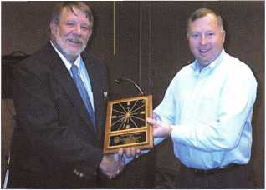

Robert “Bob” Arthur, GCC President, presenting Ken Hollenbeck, of Master Padlock with the Chairman’s Award.

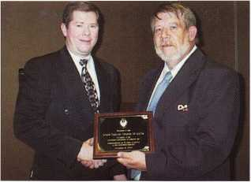

John J. Greenan, CML, CPS, ALOA  
President, presenting Bob Arthur,  
GCC President with a plaque in  
recognition of the 15 th Anniversay of  
the Grand Canyon Chapter.

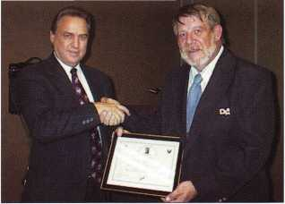

Bob Arthur presenting  
David Lowell, CML, CMST with  
the Lifetime Membership Award.

OMLA Annual Trade Show & Class

The Oklahoma Master Locksmith Association (OMLA) will hold its February Trade Show & Class on February 17, 2001 at the Holiday Inn Select, 5000 E. Skeiiy Drive, Tulsa, OK, (800) 836-9635.The trade show will run from 9:00 am until 4:00 pm. However, a free deli lunch will be provided. February’s class will be on Arrow Try-Out Keys. For additional education information contact: Jerry Rice at (405) 741-7485. For additional trade show information contact: Mike McGrew at (918) 333-9136. If you can’t make this one mark your calendars for the next class to be held on May 6. This class will be taught by D.W. Dallas and will include safe opening and tricks of the trade.

* Obits

ALOA regrettably bids farewell to one its long time members and dedicated locksmith. Marvin Long, 77 was the retired owner and operator of Long’s Lock Shop in Elkhart, Indiana. He was a second generation locksmith as well as a member of ALOA for over 40 years. Our hearts go out to the family and friends of Marvin.

* PRP

ALOA offers PRP/STPRP Testing every second Friday of the month at the ALOA Headquarters. We are located at 3003 Live Oak Street; Dallas, Texas. For more information contact: Ashley Manson at (214) 827-1701 X30.

We would like to congratulate the following individuals who recently achieved PRP/STPRP designations.

CRL

Cypert, Allen, Wahiawa, HI Deck, Michael L., Crossville, TN Donohoe, Brian, Raleigh, NC Garcia, Richard, Makailo, HI Ling, Nathan, Honolulu, HI Melvin, Christopher J., Phoenix, AZ Selent, Joseph, Otsego, MI Trepanier, Eric, Richland, MI

CPS

Pielech, Joseph, Tucson, AZ

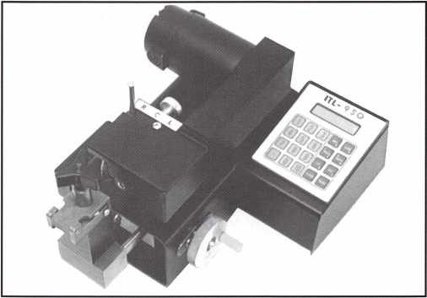

Congratulations to Louise P. Oliver of St. Thomas, Virgin Islands. She is the winner of the ITL 950 Key Machine drawing for paying her 2001 membership dues by December 31, 2000. See photo above.

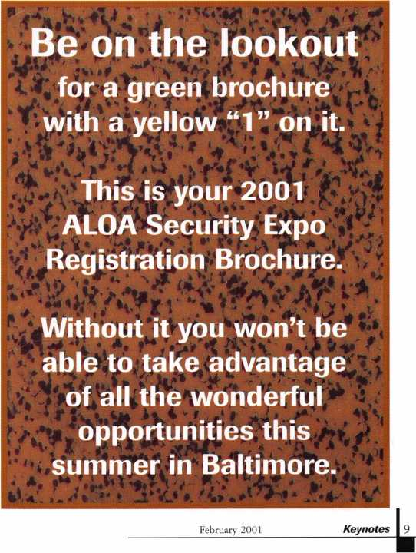

Security

Marketplace

Monaco’s “Survivor”

Marks USA has designed and is manufacturing its first decorative cylindrical lever lockset. The design matches its Monaco series of tubular locksets, but is available in most of the keyed functions. It also comes in polished brass with a Lifetime finish warranty. As in the other “Survivor” series, this lockset is built around the Marks USA “Clutch” mechanism, which is designed to extend the life of the lockset. Presently available in ANSI

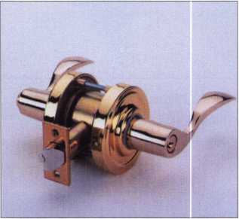

grade two, it is designed to satisfy those applications in which a decorative but reliable, heavy-duty lever lockset is required. For application assistance or brochure, contact:

Marks USA

5300 New Horizons Blvd.

Amityville, NY 11701 631/225-5400 631/225-6136 fax

Medeco’s KeyMark®

Locksmiths and other security profes­sionals are now able to upgrade Corbin Russwin locks to Medeco® quality and security with the KeyMark® Interchangeable Core cylinder. This IC core cylinder has been designed as a simple, cost-effective cylinder replacement now available to fit most Corbin Russwin hardware.

Keynotes February 2001



The KeyMark Interchangeable Core was designed to offer greater protection with a utility patent on the cylinder

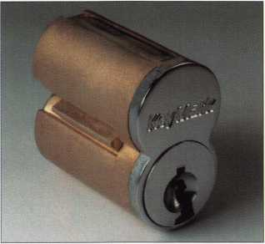

and key. The key cutting device and vice jaw are also patented for additional key control.

Medeco KeyMark systems have been used to retrofit Best and other security brands for the past five years. Compati­bility with Corbin Russwin hardware adds some versatility to the KeyMark line.

Medeco® High Security Locks 800/839-3157

Jet’s Newest Blanks

Nine new blanks have been introduced by Jet in their catalog supplement number 498.19. They include:

BL1-NP

CLP1-NP

EZ1

Ml-RV

CO-KW1

Ml-IMP

K7-NS

275RF-NS

275RG-NS

Bell

Clopay

LSDA

Master

Kwikset keyway/  
Corbin bow  
Import type  
Master locks  
Arrow large bow  
Sargent 5-pin  
RF key way  
Sargent 5-pin RG  
keyway

All new products are available on Jet’s Web site: [www.jetkeys.com](http://www.jetkeys.com). Copies of

the supplement and cross reference may

be obtained from your authorized Jet

Flardware distributor, or by contacting:

Jet Hardware

800 Hinsdale Street

Brooklyn, NY 11207

Dortronics

Dortronics Systems, Inc. has shipped its new series of power supplies employing new features and door control/alarm systems integration capabilities. The new 4200 Series Power Supplies offer field selectable 12 or 24 VDC opera­tional and integrate a fire alarm release, alarm output relays and low battery notification functions. Models are available in two and four amp versions to accommodate various door lock and alarm applications.

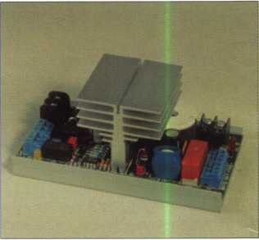

The series is available in two models: the 4202 Power Supply, featuring a 2-amp output designed for single and double electronic door lock installa­tions. The 4204 Power Supply offers a 4-amp output for installations with multiple door locks and additional security devices. Both units offer field selectable 12 or 24 VDC output for use with any electronic security device.

Dortronics new power supplies have a fail-safe fire alarm relay to assure the release of an onboard fire alarm relay and to detect ground faults in wiring to the fire alarm panel. This feature is designed to assure proper operation in the event of an alarm condition.

Additional features include: total electrical protection with fused 110 VAC and DC circuits; a built-in charging circuit to maintain optimum battery power; LED indicators to provide visual confirmation of power and battery status. For more informa­tion, contact:

Dortronics Systems, Inc. 800/906-0137 sales @ dortronics. com [www.dortronics.com](http://www.dortronics.com)

Videx CyberLock

Videx recently announced the avail­ability of their CyberLock technology in a cam style lock format. The cam lock is the newest intelligent cylinder from Videx, which also makes six-pin, mortise and rim cylinders with CyberLock technology. The 3/4-inch cam cylinder is designed to operate on a 90-degree rotation, making it ideal for cabinets, drawers, and arcade and vending machines.

The first component of the CyberLock

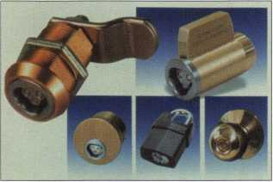

system is the cylinder. These cylinders are designed to convert existing mechanical locks into a full-functioning access control system, without the need to change the doors existing hardware. These electronic cylinders are intelligent enough to retain access passwords, a block key list, and an 1100-event audit trail that records user ID numbers, dates and times. The CyberLock cylinder contains no battery, making it ideal for outdoor environments. Battery power and access privileges can be found in the CyberKey component of the system. This intelligent key can be programmed with an event history as well, and can be programmed to grant access to specific users at specific times.

For more information, contact:

Videx

1105 NE Circle Bird.

Corvallis, OR 97330 541/758-0521 541/758-5285 fax www. videx. com

American Fibertek

American Fibertek recently introduced a new series of Fiber Optic Transceivers. This new “M Series” is designed for use with today’s popular Pan/Tilt/Zoom (PTZ) integrated camera systems.

The units feature a low profile design to facilitate easy installation in tight spaces.

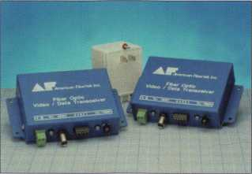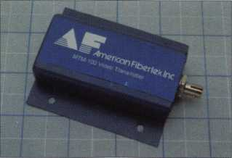

There are four models in the new series:

* Ml200 Series are multimode, single fiber, bi-directional transceivers with one-way video and return control signals designed for Philips and American Dynamic camera systems.
* M1400 Series are multimode, single fiber, bi-directional transceivers with one-way video and two-way RS422 control signals.
* Ml600 Series are multimode, single fiber, bi-directional transceivers with one-way video and reverse “up the coax” camera and PTZ control.
* The M1600P Series are multimode, single fiber, bi-directional trans­ceivers with one-way video and reverse PTZ control designed specifically for Panasonic and Proteus camera systems.

For more information, contact: American Fibertek 7321302-0660 732/302-0667 fax e-mail: [mail@americanfibertek.com](mailto:mail@americanfibertek.com) [www.americanfibertek](http://www.americanfibertek). com

NAPCO’s New Site

NAPCO Security Group has launched a new and improved Web site ([www.napcosecurity.com](http://www.napcosecurity.com)), which was designed to offer enhanced services in a user-friendly format. The totally re-designed site is meant to assist security professionals in selecting the best security and systems that NAPCO offers. The major sections of NAPCO’s new site include:

* “About NAPCO”
* “News”
* “Products”
* “International
* “Support”
* “Homeowners”
* “Investors”

You can also send product descriptions and spec sheets to other people with the “Tell a Colleague” feature, as well as contact customer service via e-mail.

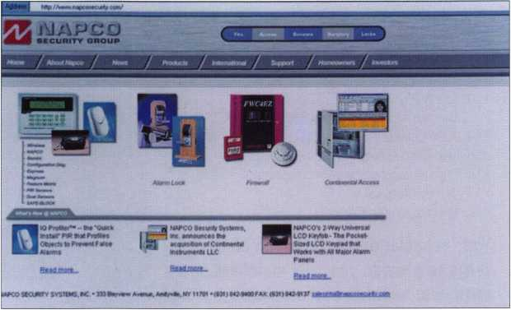

February 2001

Keynotes

Applicants

For Membership

Dept

*V The following applicants are scheduled for clearance as members  
of ALOA. The names are published for member review and comment  
prior to March 1, 2001, respectively, to ensure applicants meet standards of  
ALOA’s Code of Ethics. Protests, if any, should be addressed to the  
Membership Department and must be signed.*

|  |  |
| --- | --- |
| AP | Stanley Riden |
| APO  Barry Lamille | SPONSOR: D. Michael Lee Sr  Hampton |
| CALIFORNIA | James K Pace |
| El Cerrito  Lawrence S Vanselow | SPONSOR: Robert W. Duman CML |
| San Lorenzo | ILLINOIS |
| Robert E Bradley | Hoffman Estates  Robert W Meyer |
| COLORADO  Longmont  Connie L Cleveland | SPONSOR: Henry Raymond |
| SPONSOR: David Hansen | INDIANA  La Porte |
| Ed C Lawhorn  SPONSOR: Henry Raymond | Jennifer J Bazemore  LOUISIANA |
| FLORIDA | Houma |
| Vero Beach | Scott A McCoy |
| George E Bloomer | SPONSOR: Leo E Pahlke Jr |
| GEORGIA | |
| Atlanta | MASSACHUSETTS |
| Tim W Mealer | Maynard |
| SPONSOR: Alan Clay | William J LaBarge |

|  |  |
| --- | --- |
| MARYLAND | TEXAS |
| District Heights  Edmund Smoot | Uvalde  Roy B Hilderbran |
| SPONSOR: Henry Raymond | SPONSOR: G. Don Probasco |
| Hagerstown | VIRGINIA |
| John A Cliber | Alexandria  Robert W Noe  SPONSOR: Henry Raymond |
| Lanham  Jesse J Jackson | Mingo Gansonjr |
| SPONSOR: Henry Raymond | SPONSOR: Steve Chabo |
| OHIO | WASHINGTON DC |
| Cincinnati | Biniyam Geremew |
| Mark D Schumann | SPONSOR: Philip A. Rovenolt |
| SPONSOR: Lawrence F Smith CML | CANADA |
| PENNSYLVANIA | Kaministiquia Ontario |
| Harleysville  Charles D Gulick III | Lauri Sadko |
| TENNESSEE  Nashville  William J Neese RL  SPONSOR: Ron Harrison |  |

Need information in a hurry?

Just call 310.575.5074 and you will be faxed:

#1 A list of all documents available through this service #2 Becoming A Locksmith #3 Locksmith Career Summary #4 Locksmith School List #5 ACE Class Schedule #6 Certification Information #7 PRP Category List #8 ALOA Membership Application #9 ALOA List of Benefits #10 Scholarship Application Form #11 ALOA Video Library Order Form #12 ALOA Membership Items Order Form #13 Safe & Vault Technicians Association Member Application/Subscription Form #14 ALOA Chapter Roster #15 Legislative Action Network #16 Legislative Action Network Newsletters #17 Various State Laws #18 Industry Position Paper

ALOA  
HAS  
FAX ON  
DEMAND!

Your association continues to explore  
ways to provide you, our members,  
with new benefits and services.

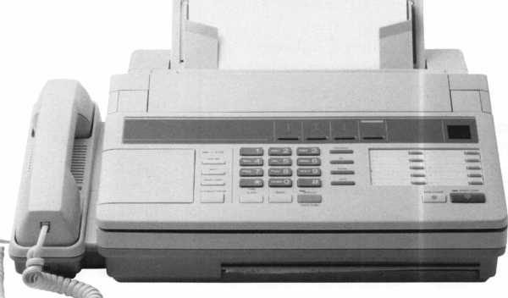

illlr

Keynotes

February 2001



PATENTED CYLINDER

Patents for lock cylinders are rare, so when a new cylinder arrives on the market, its worth taking a look. The W-LOK Corporation has patented a stainless steel cylinder housed in a stainless steel padlock. The cylinder uses nine discs that rotate 360 degrees. The result is a unique line of products, of extraordinary durability and security.

WHAT ABOUT STAINLESS STEEL?

Traditional locks consist of a steel or brass body with a brass pin tumbler cylinder, susceptible to rust and corrosion. W-LOK padlocks are com­prised of an investment cast body of 3l6w stainless steel. Because the rotating disc tumbler cylinder is also of stainless steel, these locks will not corrode. Adverse environmental conditions, salt water and road chemicals won’t affect their performance.

They are well suited for boat owners and outdoor enthusiasts who want peace of mind when they lock up their possessions. In fact, they are ideal for all outdoor applications: construction sites, utility companies, any business or entity that has gates and lockboxes. The cylinder is virtually tamper proof. The hardened stainless steel in the lead disc will stop a drill cold, and the free-rotating 360-degree discs will stymie thieves who try to force the shackle open.

Vandalism is one of the major causes of lock damage and the need to replace them. Again, this is where W-LOK products are designed to be superior to traditional locks. Common acts of vandalism include jamming super glue or chewing gum into the lock cylinder. Getting such things out of a traditional lock is nearly impossible without ruining the lock itself. The W-LOK padlock can be cleaned by the use of acid or the heat of a propane torch.

KEY SAFETY

As mentioned before, the discs in W-LOK’s rotating disc tumbler cylinder rotate 360 degrees. To open the lock, the key must be inserted until it is fully engaged and then rotated 270 degrees.

The key has a stainless steel bow and a nickel- silver shaft, which is cylindrical with a 90 degree angle cut out along the length of the shaft. A variety of angles are machined along the top edge. The result is well over a trillion possible key combinations. This allows the company to assure users that no two cylinders will be alike, unless this is specifically requested. That is, no two customers will ever receive an identical key.

Each cylinder comes with its own serial number on a warranty card. Along with the serial number, the card carries a concealed password, which is accessed by rubbing off a coating, like a “scratch and win” ticket. No one but the owner of the lock has had access to the password; there is no possibility of a duplicate key having been made.

The user who wants a key aside from the two supplied keys will need to provide the factory not only with the serial number but also with the password.

KEY CONTROL

The serial number and one-of-a-kind password, along with the fact that the keys are cut only at the factory, significantly add to customer security. This is an important safety factor for users who want to be sure that the keys are not easily duplicated and that they are protected against unwanted copies.

For institutions and corporations that want to control employee access to various areas, W-LOK offers master key systems, which allows users to have keying systems that enable one key to open all locks or only selected locks.

Body bumpers are available for each product. The Santoprene rubber bumpers come in five colors, so that locks can be color-coded for easy identification. The bumpers also help to prevent metal marring when used on a trailer or truck, or any other application where there is movement or vibration.

MODELS AVAILABLE

W-LOK has standard padlock designs in a range of body sizes and shackle diameters and depths. Along with these models, there are also guarded shackles that reduce access to the shackle. The company has a lock for receiver hitches (the Trailerlok) which offers a choice between two shackles diameters.

Some interesting designs are the Viselok, Marslok, Pinlok, and Clamplok. The Viselok can be used on hasps but it is also designed to fit on a ball trailer hitch. The Marslok is a beefy lock suited for hasps. The lock features a large-diameter shackle fortified with stainless steel on either side of the horizontally moving shackle, providing significant protection. The Pinlok has a poping (removable shackle that can be positioned at two different depths in the body of the lock. The user can select the position that best fits the application, to minimize access to the shackle. The Clamplok has a range of applications, such as securing bicycles, motorcycles, outdoor gates-even extension ladders carried on top of trucks.

Each W-LOK product carries the company’s Web address ([www.wlokcorp.com](http://www.wlokcorp.com)). Visitors to the Web site can view each model, obtain product specifications, and see some of the incredibly tough tests that have been conducted on the padlocks.

W-LOK has several new models on the drawing board - good news for the lock industry and for customers looking for high quality and high security in a cutting-edge stainless steel lock. The company is also willing to review OEM requests for lock production using its patented cylinder.

February 2001

Keynotes

\



99

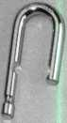

and 60s. This lock was designed with the same service and operation techniques as the original ProSeries® locks and a 3I\6 diameter shackle.

The 6835 has a solid aluminum body 19/i6 wide and a XW shackle with IV16 or 19/i6 vertical clearance.

It is available in any of six colors, (Red, Orange, Yellow, Green, Blue and Black), and is ideal for lock-out/ tag-out systems in your customers facilities. It may be ordered with the same 7000 or 6000 keys as all ProSeries®, or is also available in an SFIC version. Master Lock also offers IC’s in all the popular keyways A through M plus Q and a special keyway we call CY. The IC version, (6836), has a couple of extra parts not found in the Rekeyables with the 7000 keyway. The IC, of course, requires a throw member to transfer the motion from the IC to the extension and there is a figure 8 plate and a ‘C’ clip to retain those parts in the body when the core is removed.

The new solid brass body 6830 is l9/i6 wide with a lU" shackle, the 6840 is VU" wide with a 5/i6 shackle

called the 7000, (a five pin version of the same key way is designated 6000).

As you can see in the illustration these locks were designed with the higher security normally preferred by locksmiths in mind. Ball bearing locking for that deadbolt action that resists shimming at the shackle.

The trap door cylinder retainer is hardened against drilling. Yet, with the correct key, servicing is still easily accomplished and the function can be changed from NKR (Non Key Retaining) to NRK (Non Removable Key) with an exchange of the extension.

Another strong feature of the ProSeries® is the different shackle sizes available. The Weather Tough® and shrouded versions are available with either a Vi6 , 3/s”or Vie diameter shackle and the Weather Tough® can be ordered with a interior vertical clearance ranging from 1V8 to 53///.

Recent additions to the ProSeries® product line are an impressive selection of solid body locks. The first was the 6230, a round body with a flat bottom popularized by Hurd in the 1950’s

I guess we’ve all said that at one time or another. I know I have, until I started working for Master Lock that is. They’re still padlocks, but now I realize just how little most of us know about them.

Some say that the first lock was probably a padlock and I think I might agree. After all, does anyone really think the caveman rolled big stones in front of their caves? I think it more likely that he lashed poles together and made a ‘door’ and right after that came the first padlock.

The padlock has come a long way since its beginning and there is a variety to fit almost any need. Master Lock Co. offers around 20,000 different padlocks in its product line and the top of that line is the ProSeries® reserved for locksmiths. This line of products was started around 1992 with the introduction of the Weather Tough® and Iron Shrouded versions of the laminated padlocks. The ProSeries® offered something else new from MasterLock, six pin keying capabilities and a new locksmith only keyway

14 | KeynotesFebruary 2001

lock...

By Billy B. Edwards Jr., CML

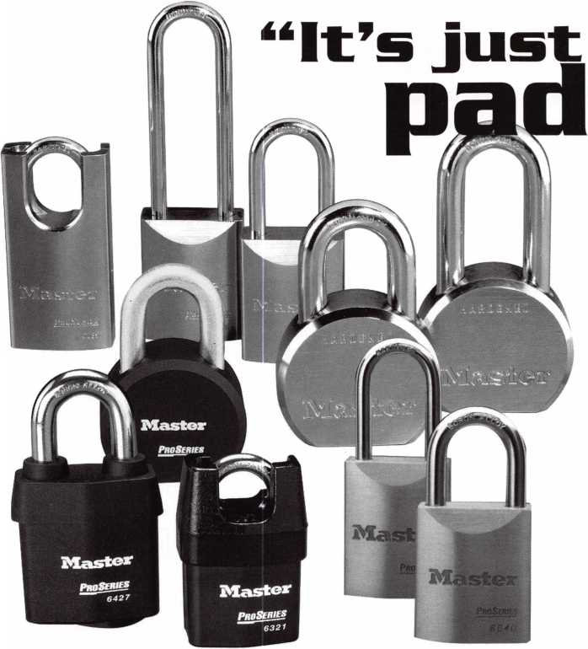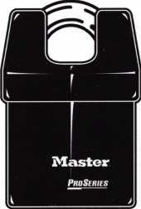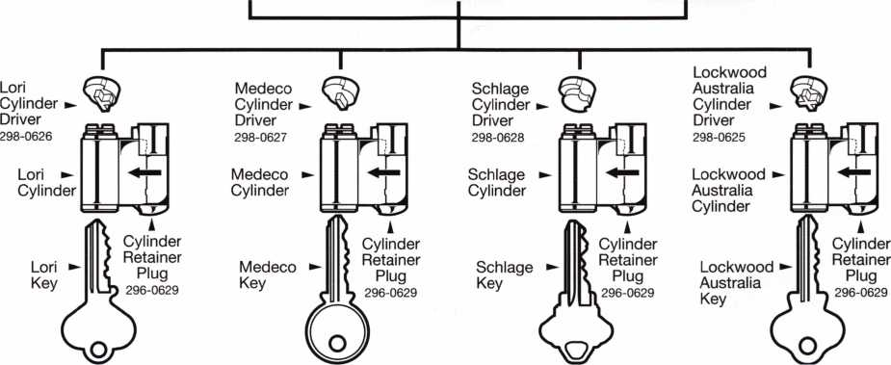

and the 6850 a 2" model with a 3/s' shackle. If you are ordering and change the last digit of those part numbers to a ‘1’, you will get the SFIC version and the 6842 and 6852 will get a lock compatible with Lori Door hardware key way cylinders. As with the IC version, you need an extra piece between the cylinder and

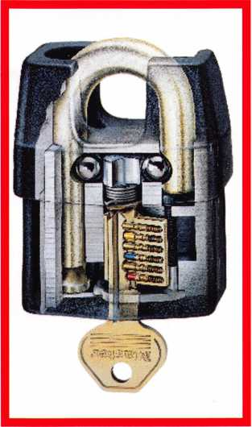

the extension to transfer the motion from the door hardware type cylinder. There are four of these drivers available to accommodate a variety of cylinders as well as the Lori type supplied from Master Lock. The different drivers are available in quantities of 6 for those who want to keep a few on-hand.

The latest addition to the ProSeries® line is immense. Known as the 7000 series, it duplicates all of the versions available as solid brass plus has shrouded versions as well. The 7030 has a l9/i6 wide body with a lU" diameter shackle, the 7031 is the IC version of the same lock. To get the shrouded version use the part numbers 7035 and 7036 respectively.

The 7040 has the l3//' wide body with a 5/i6 diameter shackle, an IC version 7041, door hardware cylinder version 7042. It is also available as a shrouded model with the same cylinder options by using part numbers 7045, 7046 and 7047 respectively.

The 7050 has the 2" wide body and a 3/s diameter shackle and the same rule of changing the last digit of the part number will get you a

7051 IC version or a 7052 door hardware model. A shrouded version of this size isn’t available at this time.

The very latest addition to the ProSeries® line is the 6270, commonly called the ‘hockey puck’. It may be ordered KA, KD or KZ (zero bitted) with your 7000 or 6000 keyway, or, with a special 600A cylinder to match a competitive product keying. The cylinder and shackle for this lock are sold separately as an assembly to accommodate those who are unsure what keyway they might need on a moment’s notice.

Master Lock Co. has developed a ProSeries® certified training course that will allow you to get hands-on experience with all the ProSeries® locks and as part of the class supplies a new technical manual with important parts breakdowns.

Those who successfully complete an exam at the end of the class are mailed a certificate suitable for framing. The next ProSeries® certified training class will be held at the ALOA convention in Baltimore so sign up early.

February 2001

Keynotes lii

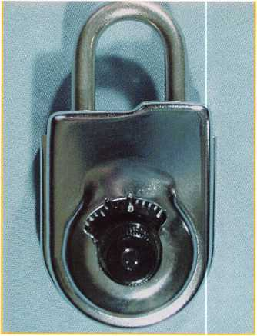

The 8077 has a distinctive appearance.

The chrome case is designed to show signs of any forced entry attempt, including drilling of small holes to view the wheels.

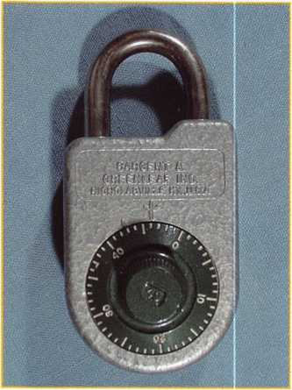

The 8088 padlock is the predecessor to the 8077. It has a gray hammertone painted case.

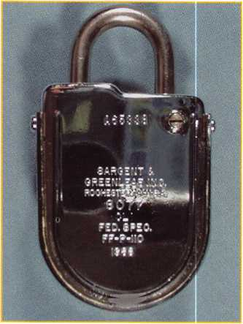

This is a rare 1968 model of the 8077.

The hack plate is polished to a mirror finish.

i

Keynotes

February 2001

Model 8077

The Exotic (not oddball) Padlock

by Brian Costley, CML, CMST

So what gives with a combination padlock that retails for $244? It’s obviously well out of the typical locker room price range, and you can’t even use it to secure the trailer hitch that tows your 54-foot cabin cruiser down the interstate, because it’s not designed for outdoor use. You would think the market for this padlock would be very, very small. In fact, thousands upon thousands are sold every year. The padlock is the Sargent & Greenleaf model 8077, and its biggest users are government agencies, both domestic and foreign, who employ it to secure file cabinets containing sensitive information.

The current incarnation of this highly specialized padlock is the 8077AD, a descendant of the earlier model 8088, and the little known model 1951 before that. All of these locks were designed to secure sensitive informa­tion in office areas. As such, their role is to act more like seals than padlocks. The thing about sensitive information is that, as bad as it is to have it stolen, it’s much more devastating to have it copied or taken without any evidence that it’s been compromised. Any security device used to protect such information needs to provide at least a moderate degree of resistance to forced entry and a very high degree of resistance to surreptitious entry (entry without leaving any evidence). Think of it this way—If you’re going to steal my secret communications codes, I want it to be obvious that they have been stolen so that I can change to new codes quickly.

The high degree of resistance to surreptitious entry is the driving force behind the design of the entire line of 8077 padlocks. The constant evolution of the product, from 8077 to 8077A to 8077AB to 8077AC to 8077AD is evidence that the level of protection against this threat is constantly being upgraded as new bypass techniques and technologies are developed by government experts. Unlike many commercial padlocks, the 8077 is constantly being tested by the best, and it’s constantly improving because of this. This focus on positive engineering changes helps explain the hefty price tag.

Since the 8077 has been the only serious padlock option for securing sensitive information for roughly 30 years, there are plenty of them out there. They get sold as surplus, many disappear after defense contracts are concluded, and some are purchased outside of government and military channels. Sales are not restricted, so anyone with the desire to own one can buy an 8077 padlock. S&G even made a few with extra long shackles a few years ago. They were destined for Europe, to be used as bicycle locks; not the best application for an indoor- only padlock. The bottom line is that there are many, many of these padlocks floating around in the world. Sooner or later, one or a bunch are bound to find their way to your service counter. Read on if you want to avoid having a confused look on your face when the moment arrives.

Most 8077s that come to you will be intact, locked up, without known combinations. The best course is to politely explain to your customer that the locks make very interesting paperweights in this condition. There is no practical way to recover the combinations without damaging the lock bodies, making them unsuitable for their intended application. Replacement parts are not available for any vintage 8077, nor will they ever become available. What good is an anti-surreptitious entry padlock if you can drill or punch it, then replace the damaged parts with new ones to make it look just like it did before you started?

If you closely examine one of these padlocks, you will notice three different serial numbers stamped into various parts; the cover, the shackle, and the back plate. When the padlock is first put into service on a file cabinet, the security supervisor for the area is charged with recording the three serial numbers found on the lock and the location where it is used. At regular intervals, or whenever a compromise of the protected material is suspected, the serial numbers can be verified to make sure no parts from another padlock were used to cover up a forced entry.

In concert with this design philosophy, the case and back plate are made with a bright chrome finish, and the back plate has a shear line, designed to break at a specific spot if it’s pried. Any attempts at drilling or prying the lock will leave obvious signs of attack. Combined with several systems that combat manipulation and other forms of surreptitious entry quite effectively, these features add up to a pretty good padlock and a formidable seal. On the other hand, all of these things combine to severely limit your service options. You can’t repair it, you can’t recover a lost combination (except under just the right conditions), and you can’t replace parts. What can you do? You can change the combination if the old combination is known, and you can recover a lost combination if the lock comes to you in just the right condition.

Changing the combination of an 8077 padlock requires focus. That’s a polite way of saying that pinning a seven-pin interchangeable core by candlelight would be an easier task. We’ll cover the procedure step by step, and I’ll show you where most end users get into trouble and decide to spontaneously convert from do-it-yourselfers to locksmith service customers.

Here are some things you should know before diving into the combination changing process:

1. The 8077 uses a 50 number dial, running from 0 to 49.
2. The lock operates on a three- number combination. Combine this with the information above, and you come up with 125,000 possible combinations.
3. There is no forbidden zone. You may use any number on the dial for any combination number. However, it is always a good idea to keep adjacent numbers at least five numbers apart. Closer numbers can easily cause confu­sion for the user when attempting to dial the lock open.
4. Dialing tolerances for the 8077 are VERY tight, and you’re working with a small dial, so number indications are quite close together. Straight-on viewing and very precise dialing are an absolute must.
5. Like a typical mechanical safe lock, the 8077 has two index marks. The opening index is at the twelve o’clock position. As the name suggests, this is the mark to which you dial all combination numbers when you want to open the padlock. The changing index is located about 3 1/2 numbers to the left of the opening index. During the combination changing process, all numbers are dialed to the changing index.
6. All 8077 padlocks leave S&G set on a single number of 25. To open a factory fresh lock, turn the dial left (counterclockwise), stopping the fourth time 25 comes to the opening index. Now turn the dial right directly to zero, and pull sharply on the shackle. If you’re pretty sure the lock is set to the factory combination and it still does not open, try dialing four times left to 24 1/2 or 25 1/2, then right to zero before pulling on the shackle. If that doesn’t work, try dialing a full number low and a full number high.
7. When dialing virtually any combination lock, whenever you pass a target number, even if you only have to move the dial a single number to get to it, that counts as one time. Here’s an example: If you have a combination that begins 37L, 32R, you will start the opening process by dialing at least four times left to 37. As you reverse dialing direction (right) to enter the second number, you pass 32 right away. That counts as one time right to 32.

To open the 8077 when it’s set on a

true, three-number combination, dial

as follows:

1. Turn the dial left (counterclock­wise) until the first number of the combination aligns with the opening index the fourth time.
2. Turn the dial right (clockwise) until the second number of the combination aligns with the opening index the third time.
3. Turn the dial left until the third number of the combination aligns with the opening index the second time.
4. Turn the dial right until zero is aligned with the opening index the first time.

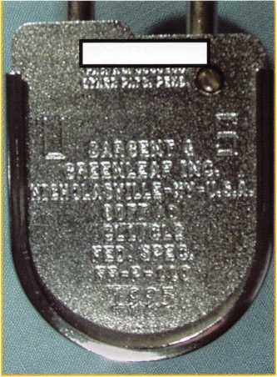

The cover plate sports a unique serial number to make sure it is not broken, then replaced with one from another padlock.

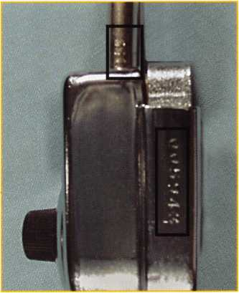

Unique serial numbers are also found on the side of the lock case and on the shackle. The number on the shackle can only be viewed when the lock is open.

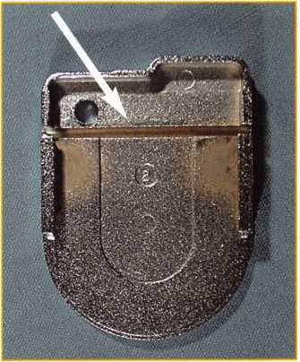

The cover is made with a shear line (or weakening groove) so that it will break at this point if it is forced.

February 2001 Keynotes L

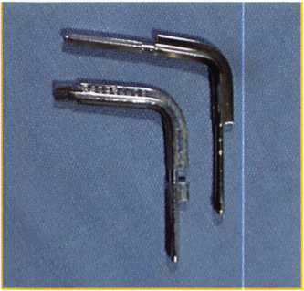

The reset key (top right) and standard change key (bottom left) are necessary tools for dealing with 8077s.

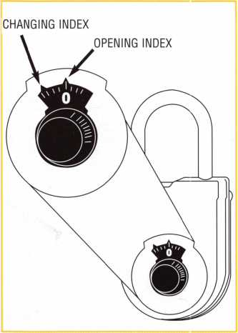

Just like most safe locks, the 8077 uses a changing index and an opening index.

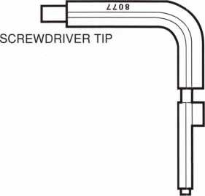

The change key has a flattened end that serves as a screwdriver to turn the cover locking screw and the large brass “screw” that controls the change keyhole cover.

The tab of the key is sometimes referred to as the “flag. ”

18 I Keynotes February 2001

1. Pull sharply on the shackle to open the lock.

Remember to always dial as precisely as you can, and maintain a straight-on viewing angle. The lock is quite unforgiving of dialing errors, no matter how small.

The manufacturer’s instructions say you should turn the dial at least five times in either direction after closing the shackle to insure the 8077 is fully locked. This is good advice, even though you will notice that you cannot reopen the shackle after closing it, no matter how careful you are to avoid moving the dial. That’s because there are “scramble fingers” inside the lock that reposition two of the wheels every time it’s closed.

Now comes the true test of courage. It’s time to change the combination. Follow each step in order if you want to be assured of success.

1. Open the padlock, following the steps listed above.
2. Note that one end of the change key (S&G part number 8077-043) is flattened. You can use this tip or a screwdriver to turn the cover locking screw clockwise until it comes to a stop. This screw cannot be turned in far enough to remove the cover unless the shackle is open.
3. When the screw is completely turned in, remove the lock cover by sliding it upward and off of the case.
4. Now turn the cover locking screw counterclockwise until it is backed out of the shackle hole as far as possible. It will not come out far enough to be removed from the padlock, and it does not have a positive stop. Just back it out until it won’t extend any farther.
5. Close the shackle of the padlock.
6. You can skip this step if you’re feeling quite confident, but I rec­ommend you take the following piece of advice. Cover the opening index with a small piece of tape (or your thumb) to prevent yourself from accidentally dialing a number to it when you should be dialing to the changing index.

7a. Dial the existing combination to the changing index as follows

ONLY IF IT IS SET TO THE FACTORY SHIPPING COMBINATION OF 25:

* Turn the dial left (counterclock­wise), stopping the fourth time 25 comes to the changing index.
* Turn the dial right until zero is

aligned with the changing index the first time.

* Go forward to step 8.

7b.Dial the existing combination to the changing index as follows

ONLY IF IT IS SET TO A TRUE, THREE NUMBER COMBINATION:

* Turn the dial left (counterclock­wise) until the first number of the combination aligns with the changing index the fourth time.
* Turn the dial right (clockwise) until the second number of the combination aligns with the changing index the third time.
* Turn the dial left until the third number of the combination aligns with the changing index the second time.
* Turn the dial right until zero is aligned with the changing index the first time.

1. Turn the brass keyhole screw on the back of the lock clockwise to the OPEN position. You can use the flat end of the change key, a screwdriver, or even a dime to do this. If the screw will not turn, re-dial the combination to the changing index, using STEP 7a or 7b, whichever is applicable to your lock.

9- Insert the change key (tip first) through the keyhole and into the lock. It is fully seated only when the tab is completely inside the lock case. The key will only go into the lock case when it is oriented correctly. When the key is fully seated, turn it clockwise 1/4 turn.

10.Set the new combination as follows:

* Turn the dial left (counterclock­wise) until the first number of the combination aligns with the changing index the fourth time.
* Turn the dial right (clockwise) until the second number of the combination aligns with the changing index the third time.
* Turn the dial left until the third number of the combination aligns with the changing index the second time.
* Turn the dial right until zero is aligned with the changing index the first time.

1. Keeping zero aligned with the changing index, turn the change key clockwise 1/4 turn and pull it straight out of the lock.
2. Again, dial your new combination numbers to the changing index as follows:

* Turn the dial left (counterclock­wise) until the first number of the combination aligns with the changing index the fourth time.
* Turn the dial right (clockwise) until the second number of the combination aligns with the changing index the third time.
* Turn the dial left until the third number of the combination aligns with the changing index the second time.
* Turn the dial right until zero is aligned with the changing index the first time.

Here comes the part where most do-it-your­selfers come to realize they have made a mistake, either in the number of turns completed in setting a particular number, or by dialing one or more numbers to the wrong index.

1. Re-insert the change key fully into the lock, but do not turn it. What you are doing is verifying that you have set the combination correctly before proceeding.

If the change key will not insert fully (until the tab is completely inside the lock case), you should jump to the reset procedure that appears later in the article.

14.If your change key can be fully inserted, remove it by pulling it straight out of the lock. Remem­ber, it is not to be turned.

1. Again, dial your new combination numbers to the changing index as follows:

* Turn the dial left (counterclock­wise) until the first number of the combination aligns with the changing index the fourth time.
* Turn the dial right (clockwise) until the second number of the

combination aligns with the changing index the third time.

* Turn the dial left until the third number of the combination aligns with the changing index the second time.
* Turn the dial right until zero is aligned with the changing index the first time.

1. Turn the keyhole screw to the closed position. If the keyhole screw will not turn, go back to step 12.
2. Close the padlock shackle.

18.If you used tape over the opening index, remove it.

1. Dial your new combination to the opening index and open the lock as follows:

* Turn the dial left (counterclock­wise) until the first number of the combination aligns with the opening index the fourth time.
* Turn the dial right (clockwise) until the second number of the combination aligns with the opening index the third time.
* Turn the dial left until the third number of the combination aligns with the opening index the second time.
* Turn the dial right until zero is aligned with the opening index the first time.

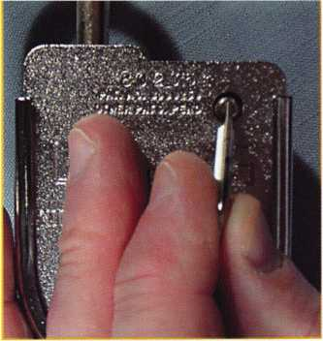

The screwdriver tip of the change key can be used to turn in the cover locking screw, which will make it possible to remove the cover.

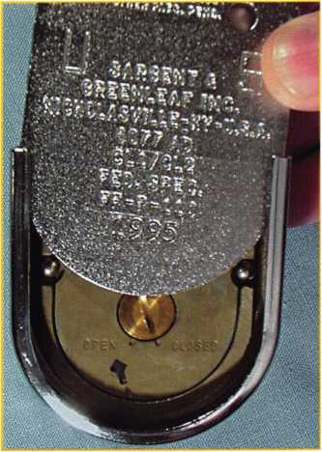

The cover slides up and off of the padlock body.

• Pull sharply on the shackle to open the lock.

1. Turn the cover locking screw clockwise until it comes to a stop.
2. Slide the cover into place on the lock body.
3. Turn the cover locking screw counterclockwise until it has extended as far as possible. Remember, it will not come out far enough to be removed from the padlock, and it does not have a positive stop. Just back it out until it won’t extend any farther.
4. Close the shackle.
5. Check your new combination by dialing open and re-locking the padlock at least three times before putting it into service.

And that’s the 8077 padlock chang­ing procedure. You’re all finished in a mere 24 steps. Anyone got a candle and pin tweezers?

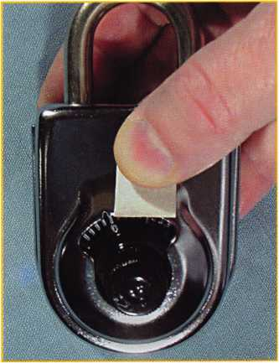

When preparing to change the combination, it is always a good idea to cover the opening index with a piece of tape. That way, you won’t accidentally dial a number to the opening index when it should have been dialed to the changing index.

February 2001Keynotes I 19

Once the old combination is dialed to the changing index {including the last turn to zero), you can use the screwdriver tip of the change key to move the keyhole screw to the “OPEN” position, uncovering the change key opening.

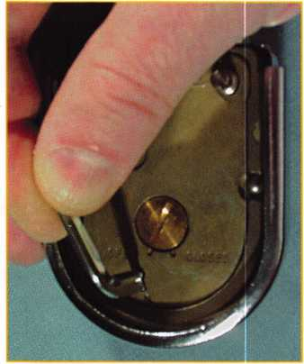

The change key will only insert if oriented correctly. Make sure the tab {or flag) of the key goes completely inside the lock case.

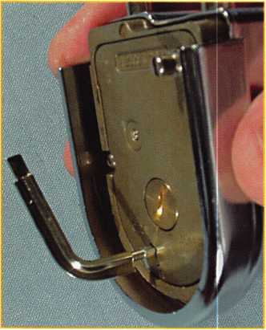

This view shows a change key that is not fully inserted into the lock. Note that part of the key’s tab {or flag) is still showing.

201 Keynotes February 2001

So much for the easy stuff. What if you get to step 13 and cannot re-insert the change key, no matter how many times you repeat the dialing process? It’s time for the magic reset key (S&G part number 8077-044), sometimes referred to as a recovery key.

In simple terms, the reset key is a standard change key that has been modified to make one end that can lock or unlock one wheel at a time, and another end that can lock or unlock all wheels simultaneously. As you might guess, this key will let you go where few have gone before.

To use a reset key, the cover must be off of the padlock, and the change keyhole must be open. If either of these two conditions is not met, the 8077 is beyond recovery, and any additional time you spend on it should be considered recreational... because it is not likely to be productive.

Take a close look at the reset key. End “A” is formed to allow you to rotate the change key cam of just one wheel at a time. It also has two bands machined into the shaft. These will be used as depth markers to tell us which wheel we’re contacting inside the lock. End “B” is made to rotate all change key cams in the same direction at the same time. It is different from a standard change key, however, in that the tab (or flag) has been machined off. This permits the key to be inserted, turned, and removed in any position.

Think about the condition the lock is in when a combination change goes awry. At least one number is set incorrectly, but all the wheels are probably locked on individual numbers. We just don’t know what they all are. If this was a safe lock, we could remove the cover, align the wheels manually, and proceed with another combination change attempt. The 8077 padlock makes things more difficult, however, since the wheels cannot be fully exposed without damaging the lock. We’ll have do whatever we can through the small change key opening in the back.

If you look through the open change keyhole as you rotate the dial, you will see the top wheel moving. This wheel carries the third, or last number of the combination. Even though it’s the first one we see move, it is referred

to as the third wheel. The wheel under the third one is the second wheel, so named because it carries the second number of the combination. The next wheel down is the first wheel. You guessed it. It’s called this because it carries the first number of the combination.

If we only needed to determine the third number of the combination, the task would be relatively simple. With good light, you could look through the change keyhole as you turned the dial. When the change key cam aligned with the change keyhole, you would just flip the padlock over and read the number under the changing index. Combination recovery is seldom that simple, however.

A simple explanation of the reset procedure goes something like this. We bring each wheel’s change key cam to the change keyhole, so that we can unlock the wheel center from the wheel case. When we have them all unlocked and aligned, we lock them all at the same time at the same position. At this point, the standard change key can be used to attempt another combination change. In practice, it’s really not much more difficult than that.

1. Insert end “A” of the reset key into the open change keyhole. Exert very light pressure against the top of the third wheel. Rotate the dial in either direction while maintaining this light contact between key tip and wheel.
2. When the change key cam in the third wheel comes underneath the tip of the reset key, the key will move farther into the lock, until the first depth mark on the key’s shaft is even with the top of the change keyhole. The dial cannot continue to rotate, because the tip of the key is trapped in the wheel’s change key cam.
3. Rotate the reset key until you hear a faint “click” and feel a release of tension within the wheel. Now you should be able to continue turning the dial, as the wheel case has been unlocked from the wheel center, allowing them to move independently.

Note: If you cannot rotate the dial more than one or two numbers, the tip of the key is not in the change key cam. Pull the key out

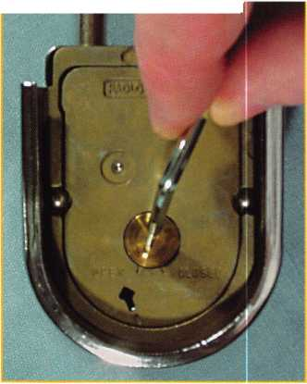

of the lock just far enough to allow you to rotate the dial. Continue turning the dial and seeking the change key cam with the tip of the “A” end of the reset key as in step 2.

1. Use light pressure to bring the tip of the “A” end of the reset key in contact with the top of the second wheel. Rotate the dial while main­taining this light contact.
2. When the change key cam in the second wheel comes underneath the tip of the reset key, the key will move farther into the lock, until the second depth mark on the keys shaft is even with the top of the change keyhole. The dial cannot continue to rotate, because the tip of the key is trapped in the wheels change key cam.
3. Rotate the reset key until you hear a faint “click” and feel a release of tension within the wheel. Now you should be able to continue turning the dial, as the wheel case has been unlocked from the wheel center.

Note: If you cannot rotate the dial more than one or two numbers, the tip of the key is not in the change key cam. Pull the key out of the lock just far enough to allow you to rotate the dial. Continue turning the dial and seeking the change key cam with the tip of the “A” end of the reset key as in step 5.

1. Use light pressure to bring the tip of the “A” end of the reset key in contact with the top of the first wheel. Rotate the dial while maintaining this light contact.
2. When the change key cam in the first wheel comes underneath the tip of the reset key, the key will move farther into the lock, until the end of the change key rib is even with the top of the change keyhole. The dial cannot continue to rotate, because the tip of the key is trapped in the wheel’s change key cam.
3. Rotate the reset key until you hear a faint “click” and feel a release of tension within the wheel. Now you should be able to continue turning the dial, as the wheel case has been unlocked from the wheel center.

Note: If you cannot rotate the dial more than one or two numbers,

the tip of the key is not in the change key cam. Pull the key out of the lock just far enough to allow you to rotate the dial. Continue turning the dial and seeking the change key cam with the tip of the “A” end of the reset key as in step 8.

End “A” of the reset key should now be fully inserted into the padlock, and you should be able to rotate the dial in either direction at least four full revolutions.

Every once in awhile, you might be presented with a lock that already has one or more wheels unlocked. This will not prevent you from recovering the lock, but it does call for a slight variation in technique.

Even an unlocked wheel will rotate as the dial is turned, providing there is no outside influence to hamper this movement. An outside influence could well be the tip of the reset key that you are pushing (lightly) against the wheel case, hoping to locate the change key cam. If it doesn’t feel like anything is moving beneath the tip of the key, use what I call the “bounc­ing” technique. Tap the tip of the key against the wheel fairly rapidly as you turn the dial. The intermittent loss of contact between the tip of the key and the wheel case will allow it to rotate in small steps. When the change key cam comes underneath the key tip, the key will immediately drop deeper into the lock case. You may have to combine this technique with variations in the angular position of the key, in case the cam is rotated somewhere between the normal setting possibilities. Is this fun, or what?

Once you have all wheels locked with their change key cams aligned with the change keyhole, carefully withdraw the reset key from the lock body. Sometimes, it is necessary to wiggle the key slightly to coax it from the lock. The difficult part is done.

Insert end “B” of the reset key through the change keyhole until the end of the key’s rib is just outside the keyhole. The angular position of the key doesn’t really make any difference. Just insert it all the way into the lock. Double check to make sure you can turn the dial at least four complete revolutions in either direc­tion. If not, you’ll have to go back to the beginning of the reset procedure.

Once you’re satisfied that everything

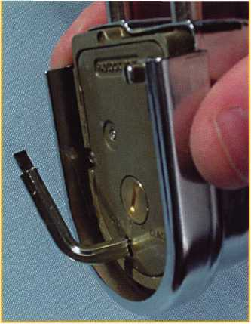

Here the key is fully inserted, with no part of the key’s tab visible. Only now should you attempt to rotate the key.

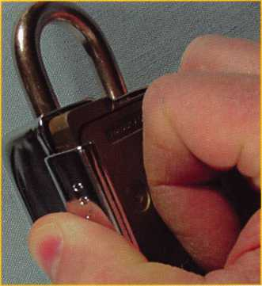

Whenever the cover is off of the lock and you are going to dial in numbers, it is a good idea to push the lock forward into the case. Hold it there anytime you are dialing in a new combination.

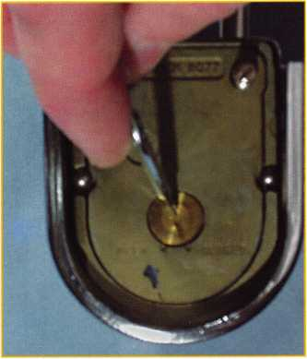

After checking to make sure you have set the new combination correctly, you can turn the keyhole screw to close the change keyhole. The complete combination must be dialed to the changing index before this can be done.

February 2001Keynotes |

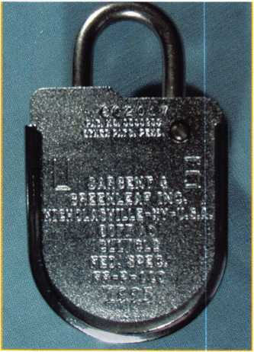

Cover installation is just the reverse of removal. Don’t forget to turn the cover locking screw out as far as it will go before attempting to close the shackle. Otherwise, it will block the toe side shackle opening.

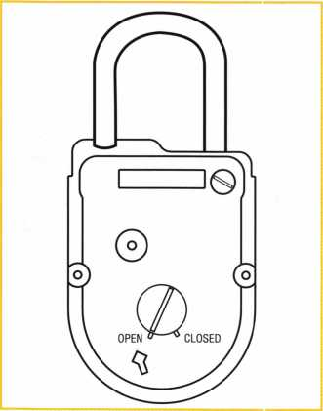

To use a reset key, the cover must be off of the padlock, and the change keyhole must be open. Otherwise, the 8077 is just a unique desk ornament.

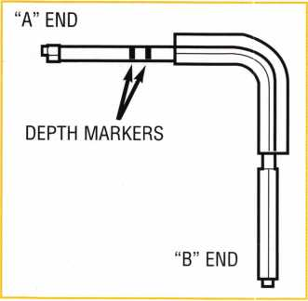

The reset (or recovery) key has an “A ” end to let you lock or unlock individual wheels.

Note the depth marker bands on the “A ” end shaft. The key also has a “B” end to lock or unlock all wheels simultaneously.

22 | KeynotesFebruary 2001

is working as planned, turn the reset key ninety degrees counterclockwise, and then pull it straight out of the padlock. It may be necessary to wiggle the key very slightly to withdraw it. Just be careful to avoid wheel movement or excessive rotation of the change key cams during key extraction.

Immediately insert the standard change key. It will only go in one way, and the orientation will be obvious by comparing the shape of the key to the profile of the change keyhole. When you turn the key clockwise ninety degrees, you’re already well into the combination changing procedure detailed earlier. Proceed to step 10 of the changing instructions.

If the padlock is not going to be put into immediate service, it’s a great idea to set it all wheels left on 25. Dial at least four times left to 25 at the changing index, then right directly to zero at the changing index. Turn the change key 90 degrees counterclockwise, remove it. Then re-dial four times left to 25, right directly to zero, and pick up the standard combination changing instructions at the point where you check to see if the change key will re-insert (step 13).

The 8077 changing procedure is lengthy, but straightforward, and everything is bound to turn out well if you follow the steps sequentially and dial very carefully. The reset procedure requires a light touch and patience. With a little practice, you can typically recover a lost combination in a minute or less. The 8077 may be a rather exotic member of the combination padlock population, but it’s easily mastered with the application of a little knowledge. And a reset key will come in handy, too.

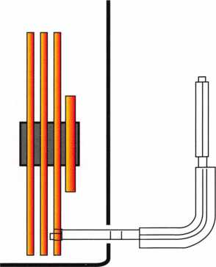

As the 3rd wheel change key cam comes under it, the reset key moves forward, bringing the first depth marker in line with the padlock case wall.

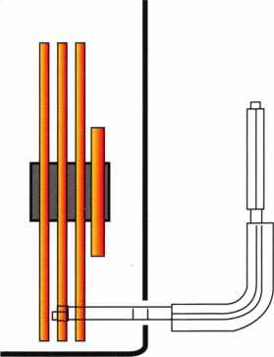

As the 2nd wheel change key cam comes under it, the reset key moves forward, bringing the second depth marker in line with the padlock case wall.

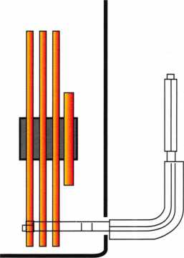

As the 1st wheel change key cam comes under it, the reset key moves forward, bringing the end of the rib of the key in Hr with the padlock case wall.

Associated Locksmiths of America

|  |  |
| --- | --- |
| Member Name | Number of Sponsorships |
| Kwok-kei Leung | 202 |
| Toshihiro Asano | 108 |
| Henry W Raymond | 93 |
| Yuriko Yanai | 68 |
| Mary S Ohmit, CPL | 66 |
| Charles C Robertson, CML | 65 |
| Jack Hobin, CPL | 51 |
| William B Neff, CML | 43 |
| Salvatore J Dulcamaro, CML | 40 |
| Myeong-Rae Cho | 38 |
| Dana L Barnum, CML | 35 |
| Barry K Leas, CRL | 35 |
| Danny W Rudd, CPL | 31 |
| Larry A Wamick, CML | 31 |
| Jeanne G Lodge, CML | 31 |
| C Allan Halverson | 29 |
| Anthony J Ramunno, CML, CPS | 26 |
| James M Watt, CML, CPS | 26 |
| Jeffrey SNunberg, CML, CMST | 26 |
| J Thomas Hood, CML | 26 |
| Jim Williams, CRL | 26 |
| Lawrence F Smith Jr., CML | 25 |
| James H Glazier Sr., CML | 25 |
| Robert H Stafford, CPL | 25 |
| William Lee | 25 |
| John C Elliott Jr., CML | 24 |
| Jerome L Cohen, CML | 23 |
| Peter K Gauthier, CPL, CPS | 23 |
| Robert F Carroll, CPL | 23 |
| Robert D DeWeese, CML | 23 |
| Marian M Swann, CRL | 22 |
| Diana R Barnum, CRL | 22 |
| Elvis D Hammerschmidt, CPL | 22 |
| James J Cawby, CML, CPS | 21 |
| Eugene R Altobella Sr | 21 |
| John L Shandy, CML | 19 |
| Hans Mejlshede, CML | 19 |
| John S Dorsey, CML | 19 |
| D Michael Lee Sr., CPL | 18 |
| James E Fowler Sr., CML | 18 |
| David C Harris, CML | 18 |
| Philip A Rovenolt, CPL | 18 |
| Peter R Hall | 17 |
| Thomas G Vandersteen, CML, CPS 17 | |
| William P Grant, CRL | 17 |
| Keizo Takahashi, CRL | 17 |
| Evelyn V Wersonick, CML, CPS | 16 |
| Joseph P Ferrero, CML | 16 |
| Gary F Teams, CPL | 16 |
| Robert W Duman Sr., CML | 16 |
| Michael D Robinson, CRL | 16 |
| Brian J Reetz | 16 |
| Maurice Benson | 16 |
| Walter W Lascar, RL | 15 |
| William J McElheney, CML | 15 |
| Russell P Fuller, CRL | 15 |
| Michael B Groves | 15 |
| Daniel L Landry Jr. | 15 |

Robert C Rodocker, CRL  
James E Gruber, CRL  
Michael E Jordan Jr., CML  
Jon B Griswold, CML  
James T Brickler, CRL  
Man S Seo

Joseph C Fuller, CPL, CMST  
Leonard J Passarello, CPL  
Frank D Hartung, CML  
Joseph W Whitaker, CPL  
Robin A Horsley  
Paul M Souber  
Donald H Shiles, RL  
Richard C Sievers  
Joe J Lee, CRL  
Ernest W Wright  
Rolando Bouza  
Raymond C Lusk, CML  
John F Engel, CRL  
Eric F Veal

Basil W Shannon, CPL  
William J Wickward, CML  
Calvin G Harris, CML  
Herbert C Dusenberry, CML, CPS  
Timothy K Chow  
Dale L Knowles, CPL  
Thomas J Demont, CML, AHC  
Alvin N Minor  
Gene Eldridge, CPL  
Ronald P Riggins, CML  
Lester S Brodsky  
Larry L Votaw, CML  
Thomas R Smith, CPL  
Richard T Johnson, CPL  
Dale V Crosby, CPL  
James V Hawley, CRL

Best.

How can I join the President's Club?

You can earn membership in this prestigious dub by  
recruiting just 10 new members for ALOA.

*Any ALOA member may participate.

What do I get?

When you recruit 10 members, you receive a handsome  
blue blazer with a President's Club crest. For each  
additional five members you recruit, you receive a  
lapel pin with gold-filled numbers, indicating your  
recruiting successes.

You also get the satisfaction of knowing that you are  
helping your association, helping your industry grow,  
and you are helping fellow locksmiths achieve success.

How do I get started?

Contact the ALOA office for a supply of applications  
(800) 532-AL0A or FAX (214) 827-1810. One President's  
Club credit is awarded for each new applicant. Credit is  
awarded only after the membership application is  
approved. Flowever, the credit will apply for the period  
in which the application is received. Failure to identify  
yourself as the sponsor on the application form at the  
time it is submitted to ALOA for processing will forfeit  
any credit.

*AL0A Board of Directors not eligible for membership in the President's Club.

February 2001

Keynotes

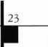

“If you want to study for the CPS test,

you need this book.

Without that book, I wouldn’t have my certification.”

-Dennis Johnson, CML, CPS  
Aurora, Illinois

"Mike's new book is very  
consistent with the study  
information required to pass the  
SAVTA/ALOA CPS certification  
test I wouldn't have passed  
without it. A tremendous  
resource for today  
and tomorrow..."

-John T. Grist; CML, CPS  
North Georgia Security

"The Safe Technicians Reference Manual by Mike Oehlert ranks among the best technical reference and learning aids you will find in the safe and vault industry. It contains page after page of essential information and easily understood illustrations. Besides answering most of the questions commonly asked by technicians new to the field, Mike has also included plenty of information experienced technicians will find useful."

-Ken Dunckel Pacifica, California

—►Over **600** Illustrations.-*—

320 **pages.** Only $135.

What are you waiting for?

To order, call 800-532-2562. Allow 3 weeks for delivery.

All major credit cards accepted; or make check payable to ALOA.

The Safe

Technicians  
Reference Manual

First Edition

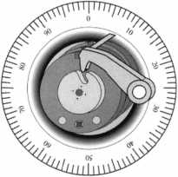

Keynotes

February 2001

by Sal Dulcamaro, CML

ABUS is known for its wide variety of padlocks. From light duty and small to heavy duty and massive, the ABUS padlock line runs the full gamut. Many padlock makers now make rekeyable padlocks and many of those offer padlocks using commercial type keyways. ABUS deals with that market niche with the 83 series commercial key way padlocks. Because you donit have to use original brand cylinders inside their lock bodies, the ABUS commercial keyway padlocks have a price advantage over many brands that come without lock cylinders.

The brass body 83/45 was introduced with a feature called the Z-Bar, which would allow you to switch the padlock back and forth from key-retaining to non key-retaining. The number following the slash mark (45) was the width of the padlock body in millimeters (metric measurement).

Converted to inch measurement 45 mm is about VIa inch­es. With a 5/i6inch diameter shackle, its a good padlock, but it is somewhat vulner­able to a pair of bolt cutters. If you need a bit more heft, though, the 83 series has two larger body padlocks. The 83/50 measures 50 mm for the padlock body, which is nearly two inches wide. It comes with a % inch diameter shackle.

If you want a really massive padlock, you are typically stuck with a padlock

February 2001

Keynotes

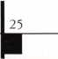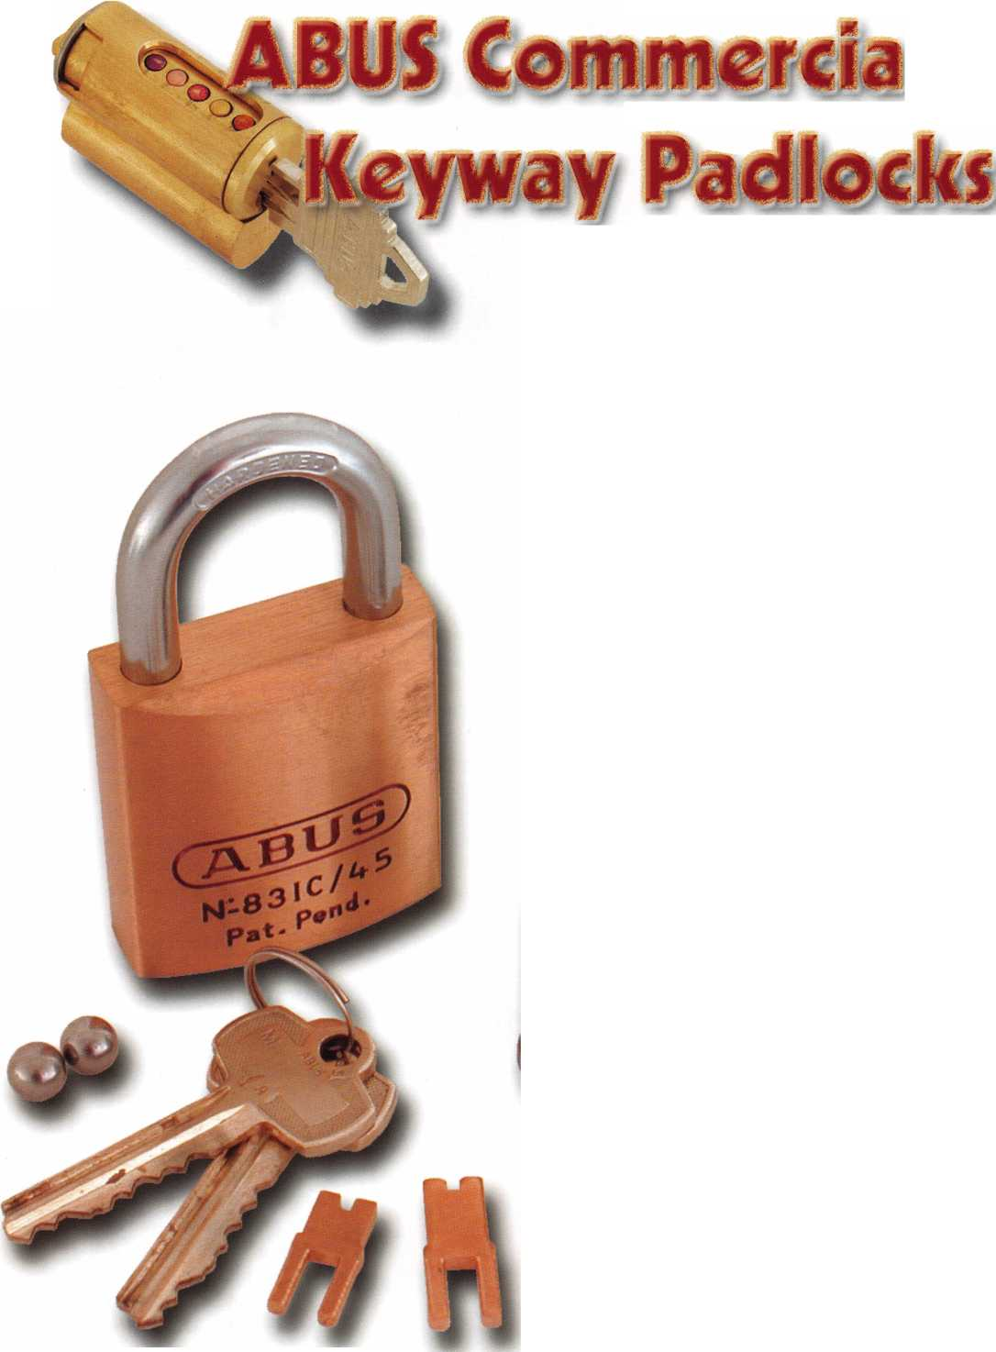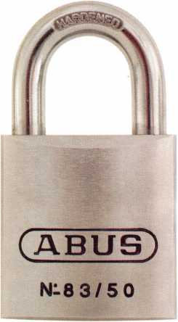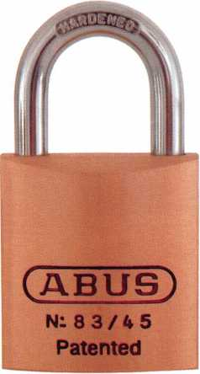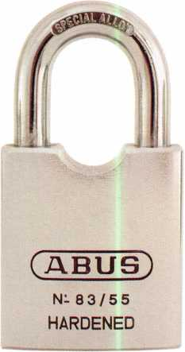

degrees, in photograph 2, you can see the five pin  
chambers exposed through a pinning “window” at the  
bottom of the lock cylinder. Where the original style  
cylinders had individual pin chamber openings, this  
version has a large opening that exposes five pin  
chambers and the spaces between the chambers. I  
have seen a number of different versions of the new  
style cylinder, and the version that you may run into  
may not look quite like this one. More likely, the  
pinning window will probably be on the side rather  
than the bottom of the cylinder.

The process of fast rekeying involves removing  
the lock cylinder from the padlock body first, by  
removing a retaining screw that is accessible through  
the shackle hole of the padlock. With the lock  
cylinder out, as in photograph 2, the key can be used  
to rotate the plug until the pin chambers are visible

in the pinning window. You only  
need to dump out the bottom  
pins, then insert a new key into  
the keyway and insert new  
bottom pins to match the cuts.  
Rotate the plug back to line up  
the upper and lower pin chambers  
and remove the new key. After  
reinstalling the rekeyed cylinder,  
reattach the retainer screw  
through the shackle hole to  
secure the cylinder inside the  
padlock body and the job is  
complete. Install the Z-Bar, if  
you want the padlock to be key-  
retaining. Leave out the Z-Bar  
and it will be non key-retaining.

The standard hardened steel  
shackle for the ABUS 83/45 and

**BUS**

N: 8 3 / 4 5  
Patented

that uses a very small padlock key. The small keyway padlocks wonit allow you to key alike office or residential door locks to padlocks. Shown in photograph 1, ABUS provides a very substantial padlock in the model 83/55. Like the other 83 series padlocks, it uses commercial keyway lock cylinders, but with a 55 mm body (approx. 2lU inch wide) and Vi6 inch diameter shackle, it may give a bit more trouble to the typical pair of bolt cutters. Like the 83/45 and 83/50 padlocks, the 83/55 also uses the same rekeyable commercial key way cylinders (with Z-Bar).

The New 83 Series Lock Cylinders

Although the lock cylinders in the ABUS 83 series padlocks have always been fast and easy to rekey, they have been slightly redesigned to make the job even easier. With the key and plug rotated 180

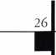

***Keynotes***

February 2001

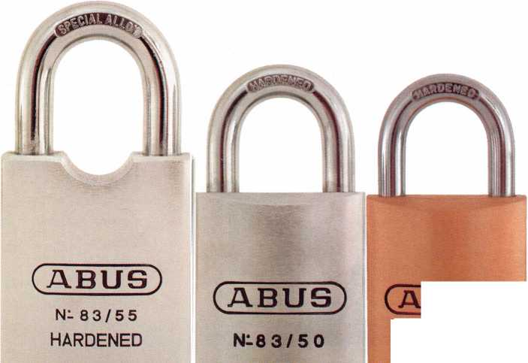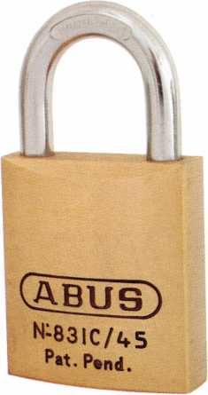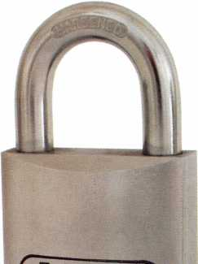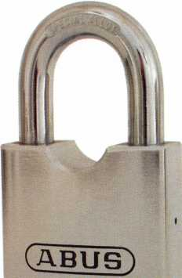

N- **83/5 5**

hardened

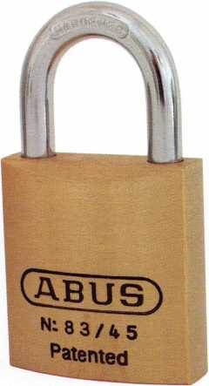

83/50 padlock has a one inch clearance. The 83/55 shackle is standard at IV2 inch clearance. Replacement shackles of different lengths and materials are available for the 83/45 and 83/50 padlocks, but not yet for the 83/55. Shackles are quickly and easily replaced, but the cylinder must be removed first.

Replacement shackles are available individually or as part of a service kit. Shackles available for the 83/45 padlock include: 1, 2, 3, 4 and 6 inch versions in hardened steel; and 1, 2, 3 and 4 inch versions in either stainless steel or brass. The 83/50 padlock is only available with 1 and 2 inch hardened steel shackles.

The ABUS 83IC/4S Padlock

already installed. Drive pins are not built into the 83IC/45 padlock, so two different length tail pieces (that fit into the back of an I-Core) are used with 6 or 7 pin I-Cores. Like the other 83 series padlocks, a Z-Bar will allow conversion from non key-retaining to key-retaining and vice versa.

For keying padlocks to standard commercial keys, the ABUS 83 series has a lot to offer. Available in most common commercial key ways, the #410 cylinder will be introduced on April 1st, with the Corbin/Russwin L4 keyway. For more info., contact: ABUS Lock Company, 3555 Holly Lane North, Suite 20, Plymouth, MN 55447. Phone: 612/509-9933. FAX: 612/509-9939.

A specialty version of the 83 series padlock is  
shown in photograph 3. It is the 83IC/45, and like  
the other 83 series padlocks, it uses commercial type

key ways. The big difference is that it  
uses Best type Interchangeable Core  
(IC) lock cylinders, which are also  
known as small format IC (SFIC).

A bottom view of the padlock is not  
shown, but would show the figure 8  
profile of an I-Core. Except for IC  
format, it is the same size as the  
83/45 brass body padlocks. Shackle  
size (and material) availability is the  
same for both the 83IC/45 and the  
83/45 padlocks. Replacement of the  
shackles is not quick and easy for the  
83IC/45 padlocks, unlike the effortless  
replacement for the standard 83/45  
padlocks. If shackles of different  
length or material are required by a  
customer, it might be smarter to order  
the padlock with the needed shackle

(ABUS)

N-83/55 HARDENED

February 2001

Keynotes

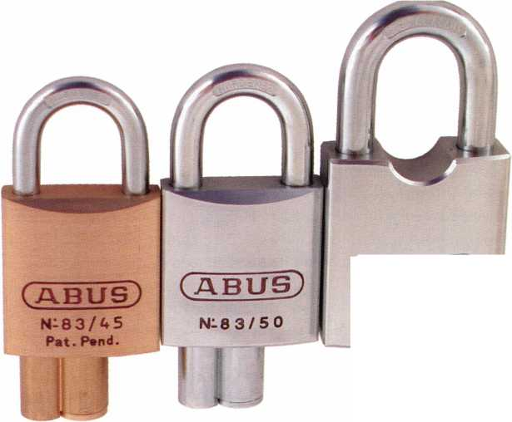

During the Christmas holidays, ALOA member Russell S. Waller, 71, died after a battle with a lengthy illness. While attending his memorial service, I thought about my 30-year association with this remarkable friend and Government servant.

Throughout the Cold War and in its unsteady wake, the diplomatic installations of the United States from Mexico City to Moscow were safeguarded by Russ’ tireless efforts to insure their physical security, often in the context of a complacent bureaucracy.

When Russ came to Washington, D.C., decades ago, he tried his hand at many things before finding the true north of his life’s journey. During Russ’ formal retirement dinner, his wife Betty shared a story of his early career move. Russ had a job working on Washington’s famous 14th Street Bridge. It literally took a fall from the thing to cause Russ to reevaluate his job, “seeing little future in it.”

This bridge provides a compelling analogy for Russ’ later career as the mainstay for U.S. government’s diplomatic physical security program. Bridges don’t stay up if people don’t pay attention to the ironwork support, until something gives way. Strengthening the Physical Protection’s girders was Russ’ goal. Russ developed an encyclopedic understanding of U.S.

Facility infrastructure abroad. He had a deep appreciation of physical security devices and he knew human engineering. While not the most visible activity of government service, but the sine qua non for the U.S. government’s ability to maintain a strong international diplomatic presence.

Early in his life, Russ was a boxer, hence the nickname “Pepper.” Despite his hot-as-pepper pugilistic

abilities, there’s simply never been a gentler guy. Russ was the kind of person who was genuinely interested in others and who loved to have a good time. One of the fondest memories my wife and I share of Russ’ was his involvement in the ALOA “candlelight” tour of the Capitol, a rare and magical event. Each of us got to ‘sit’ in the chair of The Speaker of the House. Somehow Russ, as our Federal Affairs Chairperson, fit best.

ALOA recognized his accomplishments when they featured him on the Keynotes cover , May 1994.

Those who were fortunate enough to encounter Russ at ALOA’s annual conventions, (he was easily spotted in his trademark overseas attire) recognized the enthusiasm maintained for the people involved in the ‘brass trade’ and the craft of physical security. Russ knew everyone and everyone knew Russ. Vendors knew Russ, ALOA locksmiths from all over the world knew Russ, the ALOA members from FBI, DOD and all the other branches of government service knew Russ. Individuals from various niches of the commercial industry appreciated Russ for his breath of knowledge, loyal friendship and natural charm. He wasn’t a guy that came off as, “Hey, I am a Big Deal.” He was just, “Russ” a guy with more than his share of the answers.

Russ chaired the ALOA Government Affairs Committee for years. This effort had a huge impact on Russ’ already busy schedule. Russ was the one you went to when you had a specification question, or needed advice on some scheme or device. He would tell vendors a particular new thing, based on a fine idea, would not work in the real world. He was usually right. It went further than that. Russ didn’t just toss some failed gadget back at the eager engineer, he would assist

February 2001

28 | Keynotes

with corrections — often unheralded — to resolve a problem. Russ had the ability to influence the industry, being immersed in a business that could gain from his approval. Russ was ethical and honest, never using his influence in a manipulative way. You never saw Russ change his evaluation of some product based on mercantile issues. He could be counted on to call a spade a spade — sometimes to the surprise of a three-piece suit crowd!

When you realize the depth of security knowledge needed to stay safe in hostile environments, remember many benefited from the classes taught by Russ. He selflessly shared what needed to be shared with others. Russ had a way of gathering good people into his department, and then amplifying and building their talents to teach, providing the foundation for more than one career.

A lifelong friend, Clay Miller of Lockmasters wrote, “I learned a lot from Russ over the years, as did many others. While he is not with us, the example he set will live on forever.”

Russ was a good friend, as well as a devoted family man. When he made friends, he kept them. Listening to former neighbors, and 50-year close friends John and Betty Harvil, and his children Michael and Sharon, one came away with the sense that Russ lived in the world of 72-hour days. He shared the activities of all his children, grandchildren, devoted wife of 53 years, and longtime friends. We knew this from the pictures he always had with him.

There are a few things many never heard about Russ: that he traveled with JFK when Kennedy flew abroad, teaching him to “Give me five, Pardner;” that he actually managed to get a Cowboy hat from LBJ, and so on.

With the support of Betty and their family, he managed many, many overseas trips assisting in the mission of the Department of State.

Owing to the nature of his job, bragging rights was never among the benefits. Few understood how crucial Russ was to the safety of many. Russ was never the guy telling war stories on his recent trip, nor showing photos of some faraway place.

As things developed, he simply was the Dean of the Government Lock Guys, a title not requested, but bestowed by his circle of colleagues.

Throughout it all Russ maintained a wonderful sense of humor. My personal favorite Russ story was the time both Russ and another staff member received requests for the same replacement key. It turned out both requests were made the same day from the same place, for the exact same code-cut key. Coincidences are

suspicious things, since Russ had the only full set of this particular code. What was really happening was that two bureaucrats were having a race, trying to see who could come up with the key first, though their ‘official requests’ told different stories. Russ pointed it out to me very subtly that such things just weren’t done. Each requestor promptly received half the key! They got it. With a smile.

Security and personnel protection is very serious business. Russ Waller’s legacy, shown by example: The best practitioners are those with significant personal values, commitment, technical knowledge, and a sense of humor. They should be good at Poker, too. Russ was.

Speaking for the thousands he taught, helped and protected, I’d like to thank Russ’ family for sharing such a wonderful person.

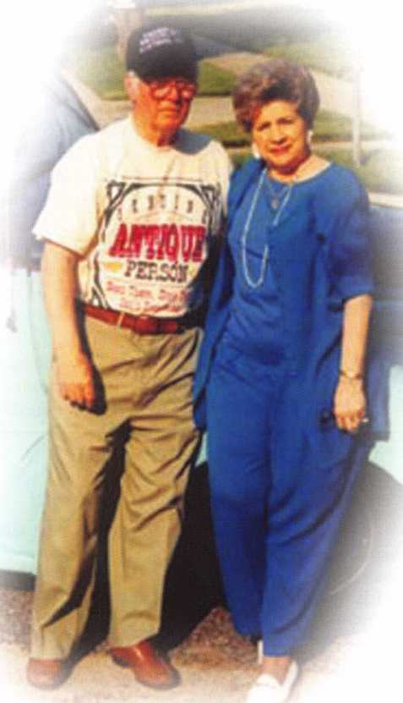

I 29

February 2001

Keynotes

By: Claire L. Cohen, CML

As professional locksmiths, we must constantly work on sharpening sales techniques. One aspect of successful selling is knowing when to bring up the subject of price of parts and labor (including service call) to a potential customer.

How and when to introduce the price of a product and/or service is important in sales strategy. If we introduce costs too soon, the prospect may not continue to listen to the rest of the presentation. The prospective customer may focus primarily on price rather than anything else. Other factors, including quality parts and professional installation must be emphasized, and that price is not necessarily the most important factor.

There are a number of important elements in helping the prospect arrive at a positive decision in your company’s favor.

Here is a suggested order to introduce price to a customer:

Explain who your company is first. It is vital that you build confidence with the prospect in the professional locksmith and in the company. Compare similar jobs done to solve like situations. Have a professional-looking notebook of installation pictures. Perhaps you could share letters from past satisfied consumer demonstrating how others felt about your quality merchandise, technical capabilities and expeditious service.

At this point introduce the price. And the prospect is now ready to hear what you have to say. If you’ve done your sales presentation properly, you now have them sold on the company, the technical expertise, the products and services and a somewhat competitive price. If the price is substantially higher than something competitive, the prospect should know what the real difference is.

Some Sales Basics

Technical selling is a deliberate destination that you focus on from the very first step. Keep control of your presentation. Let it appear that the prospect has control of the sales presentation, but in reality, you take control.

There are a number of ways to organize your sales presentation. The techniques you use to do this are important. Remember that the sales presentation organization must be understandable so the prospect can follow the points as you progress; it must be clear. Answer potential objections along the way. Offer solutions and sell benefits.

Generally, it is best to speak loud and clear. A short pause brings attention to a particular point.

The speed of your voice will often dictate if the prospect will listen and how you will or will not control the conversation. If you talk too fast, you might control the conversation, but lose the attention

It is imperative to address price in your sales presentation, as the customer must be made aware of the charges. However, if price is the way in which you are continu­ally making your own decisions, then you are apt to transfer that same feeling to your prospect.

Outline a schedule of parts, labor and timeframe that fully explains how you are going to accomplish the desired job. This should be simple and directly to the point. Emphasize those issues that set your company apart from others “why we are different.”



SAFE CORPORATION

MANUFACTURES OF QUALITY DEPOSITORY SAFES AND CHESTS

DISTRIBUTING FROM

WAREHOUSES IN

* LOS ANGLES**,** CA
* CHICAGO**;** IL
* GLASSBORO, NJ

A & B is now a stocking distributor

for Mutual Safes j——ii

featuring

uiui my

■ I

h*

|_i

AB-43035 AB-9FL WS 10-2

Chose from over 75 models in stock

We ship your order within

24 hours

See us

*of [www.o-bsafecorp.com](http://www.o-bsafecorp.com)*800-253-1267  
Fax 856-863-1208

CALL FOR YOUR  
CATALOG TODAY

February 2001

Keynotes



of the prospect. If the presentation is too slow, you may lose the attention of the prospect.

Successful security professionals will be sincere in their effort to solve the problems of those who ask to use their services. Proper attitude and appearance are important.

Taking pride in the way you handle the products you sell is extremely important to a sale. Also, making the customer feel comfortable using the product (device) he may purchase may mean the difference between a sale made or lost.

At that moment when the customer feels confident in you, the product, the services you company provides and the price quoted, that prospect becomes a client / customer.

Keep in mind that most of us have lost lock installations to people buying strictly on price. Sometimes these same people don’t even con­sider quality or service. In the end, they wonder why they are dissatis­fied when the job is done. This may be an important point to remember in your sales presentation!

We need to convert a shopper to a loyal customer. The next time, price may not be an utmost consideration when they remember the quality of merchandise and services and convenience their professional locksmith delivers.

It's True

Marray has developed the first  
screwless door loop.

Aluminum ma-  
terial means  
true anodizing.

No off color  
powder coat-  
ing or painting

Screwless base and cap means you drill two 1/2 inch diameter holes, pop the base into the hole, wire your system and snap on your covers. Simple as 1, 2, 3.

Here’s the best part We are giving away a

FREE SAMPLE TO THE FIRST lOO CALLERS WHO MEN­TION THIS ADD. A $14.40 WHOLESALE PRICE VALUE.

CALL TODAY, IT’S FREE!!

1-800-500-1449

Marray *enterprises, inc.*

At **Marray,** we’re not just modifiers, we’re Master Hardware Modifiers™ 1128 Walsh Ave., Santa Clara, CA 95050* **[www.marray.com](http://www.marray.com)**

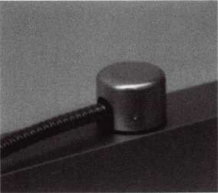

Standard 18” length. Can be ordered in cus­tom lengths

Plastic base stops shorts and pro­tects wires

February 2001

Keynotes



By David W. Tralka

Business owners in today’s market find themselves financing individual transactions, rather than planning their business growth. It’s vital to evaluate the payback of each potential new financing trans- action-your credit decisions directly affect your business profitability.

The goal of your borrowing plan should always be an improve­ment in your bottom line.

Ask yourself:

* Will this transaction increase efficiency, improve productivity or reduce expense?
* Will the credit come at a cost my business can comfortably support?
* Can I be sure that I have funds when I need them?
* Does the financing program allow me to capture new opportunities as they arise?

Financing Working Capital

To demonstrate how answering these questions can lead you to choose smart borrowing strategies, let’s take a look at one common financing need, short-term working capital.

Businesses need short-term working capital for many reasons. Perhaps your fiscal year ends just when your liquidity is lowest due to the nature of your business and you need cash flow to meet tax obligations. Or you may want to finance inventory, accounts receiv­able, operating expenses or seasonal cash lulls. For these needs, you most likely will consider a com­mercial line of credit.

In a traditional banking rela­tionship, you typically maintain three separate accounts, one each for investing, checking and borrow­ing activities. To pay down the line of credit, you generally must

request a manual transfer from the checking to the loan account.

In this arrangement, you may also be required to keep large amounts of cash in an account earn­ing a minimal amount of interest or no interest at all to provide a compensating balance for your loan. At the same time, your out­standing loans carry interest rates generally one to two percentage points above the prime rate.

All of these requirements can increase your borrowing costs, and therefor reduce your profitability.

Consider Another Strategy

You can avoid this situation and reduce your interest costs by looking for a loan program that combines cash management with loan services. If you have a central asset account that links your busi­ness’s checking, investment and borrowing activities, you may be able to obtain a prearranged line of

Forget the Service Kits! Just give me

bwd> R

• ••

acjL

Match the lock to the customer's key without having to purchase a service kit. Uncoded lock, tumblers, springs, caps, are included. Everything you need (except the key) in one easy kit.

-Fast!

-Easy!

-Cost Effective

Available through BWD Automotive Distributors!

For a listing of available Premium Pack locks and BWD's parts catalog, contact BWD at (800) 647-4926.

February 2001

I Keynotes



credit at competitive terms without the requirement of a compensating balance.

With such a lending program, incoming funds to the account are automatically used to pay down loan balances first, which mini­mizes interest expense. If you have no loan balance, incoming funds are directed to an interest-earning money market account. In either case, your funds are applied imme­diately, so your money doesn’t lie idle at any time. You can borrow only when necessary, reducing cost­ly interest expense.

At the same time, you enjoy automated cash management, elim­inating the time, worry and poten­tial errors of manual transactions. By having these activities linked under one account, you avoid over­borrowing and under-investing.

A Case History

Let’s take a look at how bor­rowing through a central asset account helped one hypothetical business save about $4,000 a year. This business owner had a $200,000 line of credit with its bank and an average outstanding loan balance of $125,000. At an interest rate of 10 percent, the business was spending about $12,500 a year in interest expense.

Switching to a central asset account, the business’s $200,000 line of credit was linked to its checking account, which had an average balance of $50,000. The checking account balance was used to reduce the average loan balance from $125,000 to $75,000. At the same interest rate, the business owner paid only about $7,500 in interest expense a year.

Even if a central asset account carries an annual fee, the total sav­ings can still be substantial. If this business owner paid an annual fee of $1,000 or .005 percent of the $200,000 line of credit, the total annual cost to the business owner would be $8,500-$4,000 less than the cost of maintaining the bank line of credit. (This illustration assumes a non-interest bearing account.)

How You Qualify

To qualify for lending pro­grams that offer smart credit solu­tions, your business has to be on a solid footing. In general, lenders will look for the following criteria:

* A business history of typically at least five years.
* Sale trends that are stable or rising.
* A history of profitability.
* An acceptable level of capital, for both the business and its principals.
* A clean record that includes no bankruptcies, material lawsuits or judgments against the busi­ness or its principals.
* A good credit history on the part of both the business and its principals.

Choose Smart Strategies

Smart credit strategies can help your business meets its financial needs, while minimizing the cost of doing business and maximizing your returns. No matter how quickly you have to make day-to- day business decisions, take the time to talk with your financial consultant about how to finance the growth of your business.

*sPEEDYPne*

THE AUTOMATIC  
KEY IDENTIFICATION  
SYSTEM

* Preprogrammed database with full side view
* Automatic inventory control and reorder program
* Create your own database(s) to match your keyboard
* Hire inexperienced personnel without training

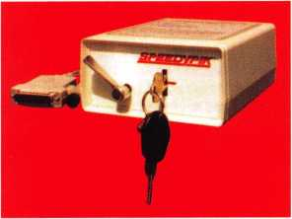

THE AUTOMATIC  
KEY DECODER SYSTEM

* Eliminates measuring each cut in a key
* Eliminates looking in pinning charts
* Portable, hand-held, battery-oper­ated
* Connects to your computer (serial port)
* Complete scan & readout in seconds

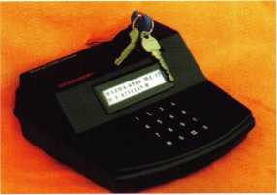

Phone: 617-567-1111  
Fax: 617-277-7777

E-Mail: SPEEDYPIK @  
AOL.COM

[www.SPEEDYPIK.com](http://www.SPEEDYPIK.com)

February 2001 Keynotes L



ALOA Heads Coalition With Other National  
Associations For The Protection Of The  
Low-voltage Industry

Not only does ALOA work in the legislative arena for locksmiths, but also in low-voltage protection from unnecessary regulations. As part of the Electronic Systems Alliance (ESA), ALOA works with 13 other associations representing companies and individuals engaged in the sales, installation, service, manufac­turing and monitoring of low- voltage electrical systems.

Low-voltage systems are home and commercial electrical systems that run on voltage under 80 volts with a current-limiting device. Such systems include access control, telephone, burglar and fire alarm, sound system, home theater, closed circuit television, home automation as well as various other low-voltage applications.

The ESA was formed to share and coordinate governmental relations issues of mutual interest to the low-voltage industries for the purpose of helping to create and maintain a regulatory environment which is conducive to the growth of the low-voltage systems industries.

The list of ESA participants include: Associated Locksmiths of America, Inc. (ALOA); Association of Cabling Professionals (ACP); Building Industry Consultant Services International (BICSI); Canadian Alarm Security Associa­tion (CANASA); Central Station Alarm Association (CSAA); Con­sumer Electronics Manufacturers Association (CEMA); Continental Automated Buildings Association (CABA); Custom Electronic Design and Installation Association (CEDIA); Electronic Industries Alliance (EIA); Home Automation Association (HAA); Massachusetts Telecom Contractors Association (MTCA); National Burglar & Fire Alarm Association (NBFAA); National Systems Contractors Association (NSCA); Security Industry Association (SIA).

If you know of any low-voltage legislation or regulations affecting your state, please contact Government Affairs Manager Tim McMullen immedi­ately at (800) 532-2562 xl6.

LEGISLAITVE UPDATE

All bills that saw movement between 01/01/2001 and 02/01/2001

MISSISSIPPI HB148

SUMMARY:

Regulates the installation and service of burglar and intrusion alarm systems; defines certain terms; creates the Mississippi electronic security board of licensure and provide for it membership and administration; provides the powers of the board; provides licensing requirements; provides exemptions from this act; provides for violations of this act; provides for uniformity; provides for its administration.

STATUS:

01/02/2001 INTRODUCED.

01/03/2001 To HOUSE Committee on JUDICIARY B

Contact your legislator about  
this bill at

<http://www.aloa.org/news/>  
legislation, cfm

ILLINOIS HB26

SUMMARY:

Provides that giving notice to the public by yellow page advertisement, through a sign at the facilities of the towing service, or by any other advertisement, that the towing service opens motor vehicle locks to enable a vehicle to be moved without towing does not constitute holding oneself out to the public as a locksmith if the advertisement does not use the word “locksmith.”

Check Out ALOA’S New On-line  
Legislative Tool!

4

Go to <http://www.aloa.org/news/legislation.cfm> and check out ALOA’s new  
on-line service that connects locksmiths to every member in their state  
legislature. It provides up-to-date information about key issues and gives  
users quick and easy access to state officials. You can contact legislators by  
customized or personalized e-mails, faxes or standard letters. It also conducts  
a 5 and 9-digit ZIP Code search so that you can identify your state and local

officials quickly. Check it out today!

Keynotes

February 2001

STATUS:

01/10/2001 INTRODUCED

01/10/2001 To HOUSE Committee on RULES.

Contact your legislator  
about this bill at  
<http://www.aloa.org/news/>  
legislation.cfm

Legislative Action Network Has Over 200 Members - Are You One Of Them?

As we continue to expand our resources and become more competitive in the legislative arena, we need the monetary resources to match our successes. You can help with as little as $14.95 to the Legislative Fund. This is only the minimum that we are asking, and encourage you to give more if you can. Those that contribute will be given a Legislative Action Network Member kit to use in their grass roots efforts. Members who donate $100 or more become Legislative Action Network Council members, and enjoy the following extra benefits: Direct input into the legislative strategic plan that guides all legislative activities; Discounts on ALOA bookstore items; 10 % rebate on all ACE classes; Complimentary Legislative Convention merchandise.

MasterLink Security Products

ROGER ALEXANDER-TUTTLE

“...understanding the needs of locksmiths...”

Mortise/Rim/Knob Cylinders • Storefront Door Hardware  
Cabinet Locks • Chain • Key Blanks • Padlocks • Pins ...and more

Local: (954) 730.9669 • Toll Free: (877) 347.9669

Fax: (954) 486.0575

e-mail: [masterlink@mindspring.com](mailto:masterlink@mindspring.com)

3863 NW 19th Street, Lauderdale Lakes, FL 33311



MLANJ 2001 Annual Convention

March 29th thru April 2nd  
Somerset, New Jersey

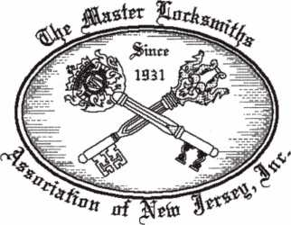

For More Information:

PO Box 2441

Morristown, NJ 07962-2441  
Phone 973-267-8884  
Fax 973-538-2248

Or visit our web site at  
[www.MLANJ.org](http://www.MLANJ.org)

February 2001

Keynotes

Keynotes

Classified

Dept

**j Classified Advertising Policy**

**Classified advertising space is provided free of charge to ALOA members, and for a fee of $.60 per word, $15 minimum for non-members. Classified ads may be used to advertise used merchandise and overstocked items for sale, “wanted to buy” items, business opportunities, employment opportunities/positions wanted and the like. Members or non-members wishing to advertise services or new merchandise for sale may purchase a “Commercial Classified Ad,” for a fee of $1.30 per word, with a minimum of $40. Each ad will run for two issues. For blind boxes there is a $5 charge to members and non-members. All ads must be submitted in writing to the ALOA office by the Fifteenth of the month, two months prior to issue date. Send to Keynotes Classifieds, 3003 Live Oak St., Dallas TX 75204-6186. ALOA reserves the right to refuse any classified advertisement that it deems inappropriate according to the stated purpose of the classified advertising section.**

■ EMPLOYMENT

Automotive Specialist Wanted

02/F/3: Relocate to beautiful Anchorage, Alaska $300 + per day. Wanted hard working automotive specialist. Must have at least 10 years of locksmith experience. Must have good driving record and good references. Must have a professional attitude. Must be honest, hard working and know all phases of automotive locksmithing. Job starts April 1. Could last a life time. No tools or equipment necessary. No medical benefits provided. This job is non-stop 10 hours a day, 5 days a week. If you are not use to hustling and working hard or doing a good job, you need not apply. Week-ends are yours to enjoy the last frontier.

Serious inquiries only.

(907) 562-5625

Qualified Locksmith Wanted

02/F/3: Wanted qualified locksmith in Bermuda. Established lock shop in operation over 50 years is looking for a locksmith with a minimum of 5 years experience for outside road work.

Safe opening experience is essential. Professional attitude, organized, good communication skills, clean driving record. Benefits include retirement plan, health insurance, paid vacation and holidays. Vehicle, tools, two-way radio provided. We’d like you to join our team. Mail resume to:

Cathy Barnes-T ucker Barnes’ Locksmith Service PO Box HM 636 Hamilton HMCX Bermuda

charnes-tucker@ihl. hm (508) 366-8864

Journeyman Locksmith Wanted

02/F/3: The University of Chicago is seeking a Journeyman Locksmith

(SEIU Local 73). Duties include installing, repairing and servicing mechanical, electrical and computerized locking devices. Will perform work in accordance with building standards and procedures for University buildings and properties. Qualifications include computer proficiency, ability to read and interpret instructions and documents, good oral/written communication skills, excellent customer service skills and a current drivers license. 4+ years related experience, completion of apprenticeship program, training programs or associates degree highly preferred. AA/EOE Please send resume to:

HR Manager 5555 S Ellis Ave Chicago, 1L 60637 (773) 834-1620 fax

Locksmith Seeking Position

02/F/3: A Certified Registered Locksmith (CRL) with over 26 years of experience in all phases of lock- smithing is seeking a Locksmith/Safe Technician Position. With experience, but not limited to: servicing residential and commercial customers; professional customer service, safe openings by manipulation as well as drilling; safe installation, moving and repairing; electronic & mechanical access control installation & repair; producing and maintaining master key systems and automotive work.

Contact:

Lester E. Pelton, CRL PO Box 3243 Ogden, UT 84409 (801) 825-6685

Locksmith Supervisor Wanted

01/F/3: Las Vegas based company that deals with all phases of surveillance, access control and locksmithing is looking for a highly qualified and motivated individual to perform

locksmith and locksmith supervisor duties. Vegas Valley Locking Systems, Inc. has a good customer base and plans to expand. Qualified individuals will have extensive experience in locksmithing, safes and door hardware. Salary DOE. Please fax resume to:

Attn: D’Anne Wells 6207 Industrial Rd Las Vegas, NV 89118 (702) 614-8052

Experienced Service Technician Wanted

01/F/3: Experienced Service Technician sought in established company in Central Illinois. Must be neat in appearance with good work habits. Godd driving record a must. Our company offers a good salary with an excellent benefit package -many EXTRAS. Send resume or contact: Denny Birt

Dave & Harry Locksmiths Inc.

116 E. University Ave Champaign, IL 61820 (217) 352-5034 (217) 352-3505 fax denny @ dave-harry.com

Automotive Locksmith Wanted

12/F/3: Relocate to South Florida and throw away your deadbolts and three keys for a dollar. We run over 300 calls per week. You must own a truck with tools and code equipment to cut all foreign and domestic keys. You can earn $800 to $1500 per week. Please if no truck or tools, no calls!

South Florida Lock and Safe (800) 928-2926

Security Technicians Needed

12/F/3: Looking for experienced, motivated, hardworking technicians and team players. Great income

Keynotes

February 2001



potential. We offer paid holidays, vacation, medical and 40IK plan. Don’t delay, fax resume today.

Liberty Lock and Safe 5470 W Sahara Ave Las Vegas, NV 89146 (702) 876-5470 www. liberty lock. com

Locksmith Wanted

12/F/3: The County of San Luis Obispo, Calif, is looking to hire a locksmith. The salary ranges from $2667-$3243 per month. For information contact:

Andy Zigan, Building Maintenance

Supervisor

(8050 781-5121

azigan @co. slo. ca. us

Service Technician Wanted

12/F/3: Locksmith service technician needed at fast paced growing firm. Looking for great pay, positive work environment and full benefits package? Fax resume to:

Mr. Schmidt

Loss Prevention Systems Inc.

22865 Savi Ranch Pkwy #B Yorba Linda, CA 92887 (714) 279-0092 fax

Service Technicians Wanted

12/F/3: Safemasters has several opportunities available for experienced technicians knowledgeable in any of the following specialties: Access Control, CCTV, Safes, or General locksmithing. Our employees enjoy flexible scheduling, 40IK and company match, health, dental and vision insurance, long and short term disability, company vehicles, opportu­nities for advancement, company paid training programs, technical skills updates, new product training, trade schools and college courses, generous leave programs, etc. We have locations in Maryland, Virginia, Wilmington

(DE), Philadelphia, Pittsburgh,

Boston, New Jersey, Indianapolis and Chicago. Stop by one of our offices and talk to a manager about your needs and how we can fulfill them. **Safemasters Headquarters Human Resources 2700 Garfield Ave, Suite 200 Silver Spring, MD 20910 hr @ safemasters. com**

M WANTED TO BUY/SELL

Key Machine For Sale

12/F/2: For sale, Taurus B Key Machine. Never used in truck, in very good shape. New $1,450, asking $725. Call:

Gene Winne (201) 327-4200

Few Items Wanted

12/F/2: We are a small, but growing business and are looking for a few items to help us grow. Looking for used Transponder Key Reader, Transponder Key Detector and a Transponder New Generation Star Tester.

James Maryon

Maryonfs Locksmith Co., Inc.

Upper Marlboro, MD (301) 627-5876

M BUSINESSES FOR SALE

Dallas Area Locksmith Business

02/P/2: Dallas Area Locksmith Business for sale. Great Market! Growth potential Unlimited! Well established commercial accounts. Includes fully equipped 1998 Chevy Van. 85K (Negotiable)

(972) 466-2003

Locksmith & Safe Repair Business

02/F/2: Locksmith and Safe Repair Business for sale. Modern, fully stocked, lock shop and mobile service.

15 years at present location.

(651) 488-6044 (651) 488-6540 fax

Locksmith Business

02/P/4: Locksmith Business in Central Florida for sale. Many established commercial and residential accounts. Owner ready for retirement. Gross sales for 1999 was 2 5 OK. Serious inquiries only! Call after 6pm EST, Monday-Thursday.

(800) 533-6658

Locksmith Shop For Sale

Ol/F/2: Must sell due to illness. Grossed 120K in 1999. Will sell for 100K or Best Offer. Serious inquiries only please contact:

William Cross (972) 241-8821

Locksmith Business For Sale

12/F/2: Established locksmith business for sale in Fairfax, VA. Same location since 1978. The store is located just outside of the nation’s capital on two major roads. Three equipped vans. Automotive, residential, banks and over 300 commercial accounts. Also handle safe opening, repairing and moving. Fully equipped store capable of cutting vats, pats, transponder and sidewinder keys.

New long term lease on store with additional warehouse/shop in rear. Owners ready to retire. Asking $270K. **Tony or Ralph (703) 273-2177**

February 2001 **Keynotes** 137

Associate

Members

Baldwin Hardware Corp.

1841 E. Wyomissing Blvd., Box 15048

MANUFACTURERS

A & B Safe Corp.

171 S. Delsea Dr.

Glassboro, NJ 08028  
(800) 253-1267; FAX (856) 863-1208

|g (g (g) g

Abus Lock Company

3555 Holly Lane North  
Plymouth, MN 55447-0507  
(800) 352-2287; FAX (612) 509-9939

©

Adams Rite Manufacturing Co.

P.O. Box 1301  
LaPuente, CA 91749-1301  
(562) 699-0511; FAX (562) 699-5094

© |g) (0 ©

Adesco Safe Manufacturing Co.

web: [www.adesco.com](http://www.adesco.com)  
email: [sales@adesco.com](mailto:sales@adesco.com)  
(800) 821 -6803; FAX (562) 408-6427

g

Adrian Steel Company

web: [www.adriansteel.com](http://www.adriansteel.com)  
Adrian, Ml 49221

(800) 677-2726; FAX (517) 265-5834

©

Alarm Lock Systems, Inc.

345 Bayview Ave.  
Amityville, NY 11701  
(800) ALA-LOCK; (516) 789-3383

©

Aiphone Intercom Systems

1700-130th Avenue, NE  
Bellevue, WA 98005  
(425) 455-0510; FAX (425) 455-0071

American Lock Co.

3400 West Exchange Road  
Crete, IL 60417-2099  
(708) 534-2000; FAX (708) 534-0531

© ©

American Security Products (AMSEC)

11925 Pacific Ave.

Fontana, CA 92337-6963  
(800) 423-1881; FAX (909)685-9685

Reading, PA 19612  
(610) 736-4012; FAX (610) 796-4493

(g) (g

Buddy Products

1350 S. Leavitt Street  
Chicago, IL 60608

(800) 886-8688; FAX (312) 733-8536

g

BWD Automotive

900 Ravenwood Dr.

Selma, AL 36701

(334) 874-9001; FAX (334) 874-6011

2J) (g

Chicago Lock Company

10100 88th Ave.

Pleasant Prairie, Wl 53158-0069  
(800) 445-3204; FAX (414) 947-7178

©

Corbin Russwin Architectural Hardware

P.O. Box 25288  
Charlotte, NC 28229  
(800) 543-3658; FAX (800) 447-6714

Ig g (g (g

Curtis Industries

6140 Parkland Blvd, Ste. 300  
Mayfield Heights, OH 44124-4103  
(800) 555-5397

g (g

DETEX

302 Detex Dr.

New Braunfels, TX 78130  
(800) 729-3839; FAX (830) 620-6711

g igi g (g g

DSC Group of Companies

3301 Langstaff Road  
Concord, Ontario, Canada  
(905) 760-3000 ext. 2200; FAX (905) 760-3040

g g g (g) (g

Don-Jo Manufacturing, Inc.

P.O. Box 929  
Sterling, MA 01564  
(508)422-3377; FAX (508) 422-3467

© ©

Door Controls International

2362 Bishop Circle East  
Dexter, Ml 48130

(800) 742-3634; FAX (800) 742-0410

g g (g g

Associate members of the Associated Locksmiths of America (ALOA) manufacture or distribute materials or equipment, or provide services, for the security industry. Many have donated money, services and equipment to ALOA in addition to their annual dues. Their support of ALOA projects enhances overall membership benefits and we encourage our members to patronize these firms. If you know of a potential candidate for associate membership, please contact the ALOA Membership staff at (800) 532-ALOA. Associate member dues are $300 per year and entitle the payor to use the ALOA logo, and receive selected discounts on ALOA products and services.

**Legend**

**© Alarms:** Personal, vehicle, electronic, fire, burglar, and exit **© Bank security equipment © Automotive:** Lockout equipment, key chains/rings

**© Builders Hardware:** Door closers, furniture/decorative hardware, viewers, emergency exit devices **© Business/Technical & Educational:** Books, reference guides, publications, computer software

**© CCTlf/Photo Imaging:** Cameras, monitors, photo ID equipment, cables © **Electric/Electronic Security:** Card access control and readers, surveil­lance, electric/magnetic locks and strikes, keypads

**© Lock Devices:** Auto locks, cylinders, emergency exit/entrance control, locks (various types), strikes **© Tools & Supplies:** Key blanks, cutters, picks, rings/hooks, custom van/truck supplies

© Safes/Vaults © Other

ESP Lock Products, Inc.

375 Harvard Street  
Leominster, AAA 01453  
(978) 537-6121; FAX (978) 534-9109

© ©

Folger Adam Security, Inc.

16300 W. 103rd Street  
Lemont, IL 60439

(630) 739-3900; FAX (630) 739-6138

© ©

Fort Lock Corp.

3000 N. River Rd.

River Grove, IL 60171  
(708) 456-1100; FAX (708) 456-9476

g g g (g (g g

Grobet File Co. of America

750 Washington Ave.  
Carlstadt, NJ 07072  
(800) 962-7242; FAX (800) 243-2432

©

Keynotes

February 2001

|  |  |  |
| --- | --- | --- |
| H.E.S., Inc. | LAB Security | ROFU International Corp. |
| 2040 W. Quail Ave. | 700 Emmett St. | 2004-B 48th Ave.; Court E |
| Phoenix, AZ 85027 | Bristol, CT 06010 | Tacoma, WA 98424 |
| (602) 582-4626; FAX (602) 582-4641 | (800) 243-8242; FAX (203) 583-7838 | (800) 255-7638; FAX (253) 922-1728 |
| (0 | • | 9 9 9 |
| HPC, Inc. | LCN Closers (Division of Ingersol) | Rutherford Controls Inc. |
| 3999 N. 25th Avenue | 121 W. Railroad Ave. | 2697 International Pkwy, Bid 5 #100 |
| Schiller Park, IL 60176 | Princeton, IL 61356 | Virginia Beach, VA 23452 |
| (847) 671 -6280; FAX (847) 671 -6343 | (815) 875-3311; FAX (815) 875-3222 | (757) 427-1230; FAX (757) 427-9549 |
| • • • | • | • |
| HID Corporation | La Gard, Inc. | STRATTEC Security Corp. |
| 9292 Jeronimo Road | 3330 Kashiwa Street | 3333 W. Good Hope Rd. |
| Irvine, CA 92618 | Torrance, CA 90505 | Milwaukee, Wl 53209 |
| (949) 568-1600; FAX (949) 568-1680 | (310) 325-5670; FAX (310) 325-5615 | (414) 247-3333; FAX (414) 247-3329 |
| • • | 9 9 9 | 9 9 9 |
| High Tech Tools | Lucky Line Products | Sargent & Greenleaf, Inc. |
| 1400S.W. 1 Street | 7890 Dunbrook Rd. | P.O. Box 930 |
| Miami, FL 33135 | San Diego, CA 92126 | Nicholasville, KY 40340-0930 |
| (305) 649-7014; FAX (305) 541-0074 | (619) 549-6699; FAX (619) 549-0949 | (606) 885-9411; FAX (606) 887-2057 |
| • • | • | 9 9 9 9 |
| Hongtai Lock Co. Ltd. | M.A.G. Engineering & Mfg. Inc. | Schlage Lock Co. |
| Jidong, Xiaolan Road, Xiolan | 15381 Assembly Lane | 1915 Jamboree Suite 165 |
| Zhongshan/Guangdong, China 528415 | Huntington Beach, CA 92649 | Colorado Springs, CO 80920 |
| (86) 137-238-1414; FAX (86) 208-793-3856 | (714) 891-5100; FAX (714) 892-6845 | (800) 847-1864; FAX (800) 452-0663 |
| • • • • | 9 « • | • 9 |
| llco Unican | MARKS USA | Schwab Corporation |
| 400 Jeffreys Road | 5300 New Horizons Blvd. | 110 Professional Court |
| Rocky Mount, NC 27804 | Amityville, NY 11701 | Lafayette, IN 47905 |
| (252) 446-3321; FAX (252) 446-4702 | (516) 225-5400; FAX (516) 225-6136 | (765) 447-9470; FAX (765) 447-8278 |
| ^ (Q) @ (p (j^ (p ^ | • | • |
| In Out Systems, Inc. | MARRAY ENTERPRISES | Securitron Magnalock Corp. |
| 3650-B Matte Boulevard | 1128 Walsh Avenue | 550 Vista Blvd. |
| Brossard, Quebec J4Y-2Z2, Canada | Santa Clara, CA 95050 | Sparks, NV 89434 |
| (450) 444-5949; FAX (450) 444-4856 | (408) 970-0213; FAX (408) 970-8767 | (800) 624-5625; FAX (702) 355-5636 |
| 9 9 | 9 9 9 | <0 9 |
| Intellikey | MUL-T-LOCK USA, Inc. | Security Door Controls |
| 551 S. Apolo Boulevard, Suite 204 | 300-1 Route 17 South Suite A | 3580 Willow Lane |
| Melbourne, Florida 32901 | Lodi, NJ 07644 | Westlake Village, CA 91361 |
| (800) 226-0703; FAX (407) 724-0811 | (800) 562-3511; FAX (973) 778-4007 | (805) 494-0622; FAX (800) 959-4732 |
|  | 9 9 9 | • |
| Jet Hardware Mfg. Co | Master Lock Company | Security Solutions |
| 800 Hinsdale Street | 2600 North 32nd Street | 1640 W. Hwy. 152 |
| Brooklyn, NY 11207 | Milwaukee, Wl 53211 | Mustang, OK 73064 |
| (718) 257-9600; FAX (718) 257-0973 | (414) 444-2800; FAX (414) 449-3114 | (405) 376-1600; FAX (405) 376-6870 |
|  | 9 9 | 9 9 9 |
| KABA High Security Locks | Medeco Security locks | Sentry Group |
| P.O. Box 490 | P.O. Box 3075 | 900 Linden Ave. |
| Southington, CT 06489 | Salem, VA 24153 | Rochester, NY 14625-2784 |
| (860) 621 -3601; FAX (860) 621 -9727 | (540)380-5000; FAX (540) 380-5010 | (716) 381 -4900; FAX (716) 381 -8559 |
| • | • 9 9 | • |
| KEY-BAK; Div. of W. Coast Chain Mfg. Co. | Meilink Safe Company | Sully Tools Inc. |
| 4245 Pacific Privado | 111 Security Parkway | 3515 Nodding Pine Ct. |
| Ontario, CA 91761 | New Albany, IN 47150 | Fairfax, VA 22033 |
| (909) 923-7800; FAX (909) 923-0024 | (800) 634-5465; FAX (800) 896-6606 | (703) 689-3416; FAX (703) 787-0869 |
| 9 9 9 9 | • | • • • |
| Knaack Manufacturing Co. | One Lock, One Key Inc. | Taymor Industries, Inc. |
| 420 E. Terra Cotta Ave. | 706 Hinsdale Dr | 1586 Zephyr Ave. |
| Crystal Lake, IL 60014 | Arlington, TX 76006 | Hayward, CA 94544 |
| (800) 456-7865; FAX (815) 459-9097 | (817) 860-1011; FAX (817) 275-6839 | (800) 388-9887; FAX (800) 288-8133 |
| • | • | # • |
|  |  |  |

February 2001

Keynotes



|  |  |  |
| --- | --- | --- |
| Trine Products Corporation  1430 Ferris Place  Bronx, NY 10461  (718) 829-4796; FAX (718) 792-9127  (g> (0 (g | ADI  263 Old Country Road  Melville, NY 11747 (516) 692-1000; FAX (516) 692-3457  g g g | E. L. Reinhardt Co., Inc.  3250 Fanum Road  Vadnais Heights, MN 55110 (800) 328-1311; FAX (612) 481 -0166  g g (U g g g |
| Unelko Security Systems Ltd.  14641 N. 74th Street  Scottsdale, AZ 85260 (480) 991-7272; FAX (480) 483-7674  (JJ) | Akron Hardware Consultants, Inc.  2579 South Arlington Road  Akron, OH 44319  (800) 321 -9602; FAX (800) 328-6070  g g g | Ewert Wholesale Hardware  4709 W 120th St  Alsip II 60658  (800) 451 -0200; FAX (708) 597-0881  g g g g g |
| Videx, Inc.  1105 NE Circle Blvd.  Corvallis, OR 97330 (541) 758-0521; FAX (541) 752-5285  g (|^ g | American Security Distribution  4411 E. La Palma  Anaheim, CA 92807 (714) 996-0791; FAX (714) 579-3508  g g g g g g g | Fairway Supply, Inc.  2631 Lombardy Lane  Dallas, TX 75220  (214)350-0021; FAX (214) 352-4299  g g g g (0) g g |
| Visonic, Inc.  10 North wood Dr  Bloomfield, CT 06002 (800) 223-0020; FAX (860) 242-8094  © | Andrews Wholesale Lock Supply  544 S. 9th St.  Lebanon, PA 17042-6608 (717) 272-7422; FAX (717) 274-8679  g | Foley-Belsaw Company  6301 Equitable Road  Kansas City, MO 64120 (800)821-3452; FAX (816) 483-5010  g g g g |
| W-Lok Corporation  675 East 16th Street, Suite 111  Holland, Ml 49423  (616) 355-4015; FAX (616) 355-4295  © | Boyle & Chase Inc.  P. O. Box 74  Accord, MA 02018-0074 (800) 325-2530; FAX (800) 205-3500  g g (0) | Fried Brothers, Inc.  467 N. 7th St.  Philadelphia, PA 19123 (800) 523-2924; FAX (800) 541 -3489  gggggggggg |
| Weiser Lock Company  6700 Weiser Lock Blvd.  Tucson, AZ 85746  (502) 741 -6338; FAX (520) 741 -6363  g (0 | Clark Security Products, Inc.  4775 Viewridge Ave.  San Diego, CA 92123-1641 (800) 854-2088; FAX (619) 974-5284  gggggggggg | HS&S Wholesale Distributors  12915 West 8 Mile Road  Detroit, Ml 48235  (800) 521 -2202; FAX (313) 342-7580  g g g g (0) g g |
| Wilson Bohannan Company  621 Buckeye Street  Marion, OH 43301 -0504 (800) 382-3639; FAX (740) 383-1653  © | Cook's Building Specialties  2441 Menaul Blvd. NE; P.O. Box 37320 Albuquerque, NM 87176-7320 (505) 883-5701; FAX (505) 883-5704  g 0 g g g g | Hans Johnsen Company  8901 Chancellor Row  Dallas, TX 75247  (214) 879-1550; FAX (214) 879-1530  gggggggg |
| Yale Security Inc.  P.O. Box 25288  Charlotte, NC 28229-8010 (800) 438-1951; FAX (800) 338-0965  g g g g | DiMark International  3117 Liberator St., Unit A  Santa Maria, CA 93455 (800) 235-2435; FAX (805) 928-8034  g g g g g | Hardware Agencies, Ltd.  1 220 Dundas Street East  Toronto, ON M4M 1 S3 (416) 462-1921; FAX (414) 462-1922  gggggggg |
| Zhongshan Hua Feng Lock Products  S Yongning Industrial Road, Ziaolan Zhongshan Guangdong, China  86-760 227 82 63; FAX 86-270 227 80 63  ® | Dire's Lock & Key Co.  2201 Broadway  Denver, CO 80205  (303) 294-0176; FAX (303) 294-0198  ggggggggggg | Hardware Suppliers of America  P.O. Box 2208  Winterville, NC 28590 (800) 334-5625; FAX (800) 334-5635  g g |
| DISTRIBUTORS | Direct Security Supply, Inc.  36 Lincoln Street  Boston, MA02135  (800) 252-5757; FAX (800) 452-8600  g g g ||g g g | High Tech Tools  1400S.W. 1 Street  Miami, FL 33135  (305) 649-7014; FAX (305) 541 -0074  g g |
| Accredited Lock Supply Co.  P.O. Box 1442  Secaucus, NJ 07096-1442 (800) 652-2835; FAX (201) 865-5031  g g g © g ® © | Doyle Security Products  2211 W. River Road N.  Minneapolis, MN 55411 (800) 333-6953; FAX (612) 521-0166  ggggggggggg | Howard Keys  1 30 Stetson Dr  Charlotte, NC 28262 (704) 598-2291; FAX (704) 598-9110  ©  IDN, Inc.  2401 Mustang Drive, Suite 100  Grapevine, TX 76051 (817) 421 -5470; FAX (817) 421 -5468  gggggggggg |
| Ace Lock & Security Supply Co.  565 Rahway Ave.  Union, NJ 07083-6631 (800) ACE-LOCK; (800) ACE-FAX4  gggggggg | Dugmore & Duncan Inc.  30 Pond Park Rd.  Hingham, MA 02043 (888) 384-6673; FAX (888) 329-3846  g g g (0 g g g |

401

Keynotes

February 2001

|  |  |  |
| --- | --- | --- |
| Intermountain Lock & Supply Co  3106 South Main Street  Salt Lake City, Utah 84115 (800) 453-5386; FAX (801) 485-7205  0000000000 | Securite.com  4775 Viewridge Avenue  San Diego, CA 92123 (800) 241-3930; FAX (619) 974-5269  0 0 0 | U.S. Lock Corporation  77 Rodeo Drive  Brentwood, NY 11717 (800) 925-5000; FAX (800) 338-5625  0 0 0 0 0 |
| JLM Wholesale, Inc.  3095 Mullins Ct  Oxford, Ml 48371-1643 (800) 522-2940; FAX (800) 782-1160  0 0 0 | Omaha Wholesale Hardware  1201 Pacific Street, PO Box 3628  Omaha, NE 68108 (800) 238-4566  00000000 | Webster Safe & Lock Company, Inc.  3020 Millbranch  Memphis, TN 38116 (901) 332-2911; FAX (901) 332-2878  0 0 0 0 0 0 0 |
| Jo-Van Distributors Inc.  929 Warden Ave.  Scarborough, Ontario Ml L 4C6 (416) 752-7249; FAX (416) 752-3845  00000000000 | Security Lock Distributors  40 A Street  Needham Heights, MA 02194 (800) 847-5625; FAX (800) 878-6400  0 0 0 | SERVICE |
| Lockmasters, Inc.  5085 Danville Road  Nicholasville KY, 40356 (800) 654-0637; FAX (859) 885-7093  0 0 0 0 | Sentry Security Fasteners  8109 N. University  Peoria, IL 61615  (309) 693-2800; FAX (309) 693-2872  § ® | 1 -(800) Tow Truck, Inc.  190 Main Street  Hackensack, NJ 07601 (800) 835-4187; FAX (800) 835-4189 |
| Locks Company  2050 N.E. 151 St.  N. Miami, FL 33162 (800) 288-0801; FAX (305) 949-3619  0) (0) (0 (0 (0 (0 | Southern Lock and Supply Co.  Box 1980, 10910 Endeavor Way  Pinellas Park, FL 33780 (800) 237-2875; FAX: (800) 447-2299  000000000 | Alarm Monitoring Service, Inc.  5021 Fairfield St.  Metairie, LA 70006 (504) 454-2163; (504) 456-8737  • |
| The Locksmith Store Inc.  1229 E Algonquin Rd. Suite E  Arlington Heights, IL 60005 (847) 364-5111; FAX (847) 364-5125  0) (0) (0 (0 | Stone & Berg Wholesale  99 Stafford Street  Worcester, MA 01603 (800) 225-7405; FAX (800) 535-5625  0000000000 | Allstate Insurance Company  2775 Sanders Road, Suite A5  Northbrook, IL 60062 (847) 402-8196; FAX (847) 326-7509 |
| M. Zion Company  69 Reade Street, 4th Floor  New York, NY 10007 (212) 349-8677; FAX (212) 964-0495  0 0) (0 0 (0 0 (0 | Strauss Safe & Lock Company  1801 Second Avenue  Des Moines, IA 50314 (515)288-9571; FAX: (515) 288-9752  0 0 0 0 0 0 | Diamond Software  2952 N. Expressway  Griffin, GA 30223  (770) 227-7650; FAX (770) 227-1699  @ |
| McDonald-DASH Locksmith Supply  5767 E. Shelby Dr.  Memphis, TN 38141 (800) 238-7541; FAX (901) 366-0005  00000000 | Tanner Bolt & Nut Corporation  4302 Glenwood Road  Brooklyn, NY 11210 (718) 434-4502; FAX (718) 434-3215  ® | Locksmith Publishing Corp.  850 Busse Hwy.  Park Ridge, IL 60068 (847) 692-5940; FAX (847) 692-4604  • |
| McManus Locksmith Supply, Inc.  P.O. Box 9231, 1309 Central Ave.  Charlotte, NC 28299 (702) 333-9112; FAX (704) 332-8664  0 0 0 0 (0 0 | Taylor Securtiy & Lock Co.  8585 Atlas Drive  Gaithesburg, MD 20877 (301) 948-7670; FAX (301) 948-1029  0 0 0 0 | ® Alarms  © Bank Security Equip.  ® Automotive  © Builders Hardware  © Business/Tech & Ed.  ®CCTV/Photo Imaging  10 Electric/Electronic Security © Lock Devices ® Tools & Supplies © Safes/Vaults  ©Other |
| McMaster-Carr Supply Company  600 County Line Rd,  Elmhurst, IL 60126-2081 (630) 833-0300; FAX (630) 834-9427  0 0 0 0 (0 0 | Timemaster, Inc.  127 SE 29th Street  Topeka, KS 66605  (785) 232-8705; FAX (800) 798-8463  0 0 0 0 0 0 0 |
| MARRAY ENTERPRISES  1128 Walsh Avenue  Santa Clara, CA 95050 (408) 970-0213; FAX (408) 970-8767  0 0 0 | Top Notch Distributors, Inc.  3151 Goni Rd.  Carson City, NV 89706-7922 (800) 722-4210; FAX (800) 248-3620  0 0 0 |
| Monaco Lock Co.  339-345 Newark Ave.  Jersey City, NJ 07302 (800) 526-6094; FAX (800) 845-LOCK  0 0 0 | Turn 10  P. O. Box 746  Marietta, OH m45750 (800) 848-9790; FAX (800) 391 -4553  0 0 |
|  |  |

February 2001

Keynotes 1_

Keynotes

Authors

Diane Broekhuis is the President ofW-Lok Corporation.

Claire L. Cohen, the second woman to become a CML, has been in locksmithing since 1977 and has been writing articles for Keynotes since 1987. She is also a contributing editor for Keynotes.



Brian Costley, CML, CMS was the 1995  
ALOA (ALOA Lifetime of Outstanding  
Achievement) Award winner and has been  
involved with the security industry for over  
25 years. He's contributed to a variety of  
trade publications and is the director of

Customer Services for Sargent and Greenleaf.

Billy B. Edwards Jr., CML is the Key Records Manag­er for Master Lock and the author of Master Keying by the Numbers. He is also the past recipient of the Philadelphia Award and serves as a Co-Chairman of the LIST Council.



INTERCHANGEABLE  
CORE PRODUCTS

Interchangeable gfiA|H| with:

* best lm
* ARROW Y* »J s

•FALCON

CONTROL

Quality • Price Delivery

KSP

KILLEEN SECURITY  
PRODUCTS

That’s what KSP is all about!

Ask your wholesaler about  
our drop shipping**.**



***33 Hermon St.  
Worcester,*** H4 ***01610  
Phone (508) 708-3200  
Fax (508) 753-2183***

I Sal Dulcamaro, CML, has been in the locksmith business for over 25 years. He is «?■ the president of All Pro Security, Inc. in

Michigan and has been an ALOA member for 18 years. A past president of the Locksmith

^—— 1 Security Association of Michigan. Sal currently

serves as editor of the association newsletter.

He was named ((Keynotes Author of the Year” for 1996 and 1997. He is also a contributing editor for Keynotes.

David J. Killip has been an active member of ALOA for 33 years.



Tim McMullen oversees legislative affairs for ALOA. He is a graduate of the District of Columbia School of Law and has an extensive background in legislative work.

David W. Tralka is a freelance writer.

|  |  |
| --- | --- |
| Keynotes Advertisers Index | |
| Advertisers | Page |
| A & B Safe | 30 |
| ALOA 2001 | 1 |
| BWD Automotive Corp. | 32 |
| KSP | 42 |
| Marray Enterprises Inc. | 31 |
| MasterLink Security Products | 35 |
| MLANJ | 35 |
| SAFETECH 2001 | IBC |
| Safe Technicians Ref Manual | 24 |
| SpeedyPik | 33 |
| STAM Insight | 5 |
| STRATTEC | IFC |
| W-LOK | BC |

***Keynotes***

February 2001

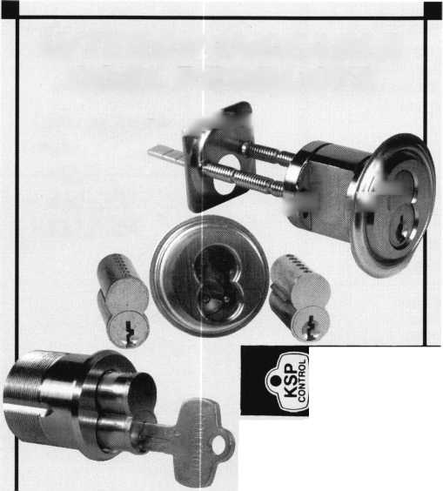

More than 40 years ago, Grandma gave you some Series E Savings Bonds.

So you put them in a safe place and forgot about them—until now. You were looking for old  
records, but you found an unexpected treasure instead ... those old Series E Savings Bonds.

And even though your old bonds are no longer earning interest*, they could still be worth  
more than 5 times their face value. So why not put your money back to work?

Redeem those old bonds for cash, or if they qualify, exchange them for Series HH Savings Bonds at your local financial  
institution. To find out more, call 1-800-4US BOND, or write to Savings Bonds, Parkersburg, WV 26106-1328 and

ask for a current values chart. Old Savings Bonds.

They're a treasure worth digging for.

Creating a

New Century **_**

of Savings'

*SAVINGS*

*.BONDS*

Do you have old Savings Bonds? Check out the Savings Bond Calculator at

**[www.savingsbonds.gov](http://www.savingsbonds.gov)** to discover their value.

* Pre-December 1965 Series E Savings Bonds stop earning interest  
at 40 years, and those purchased after November 1965 stop at 30 years.

A public service of this publication

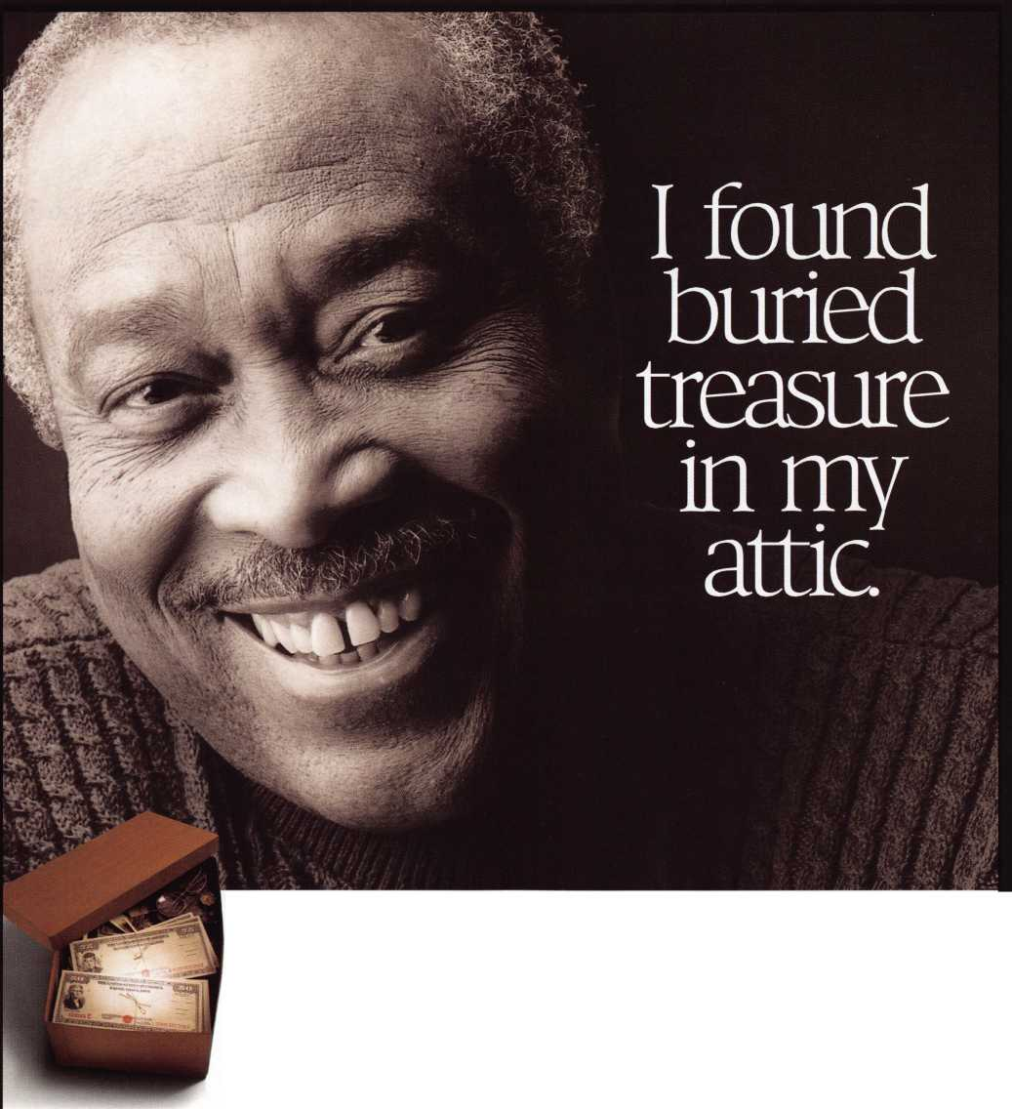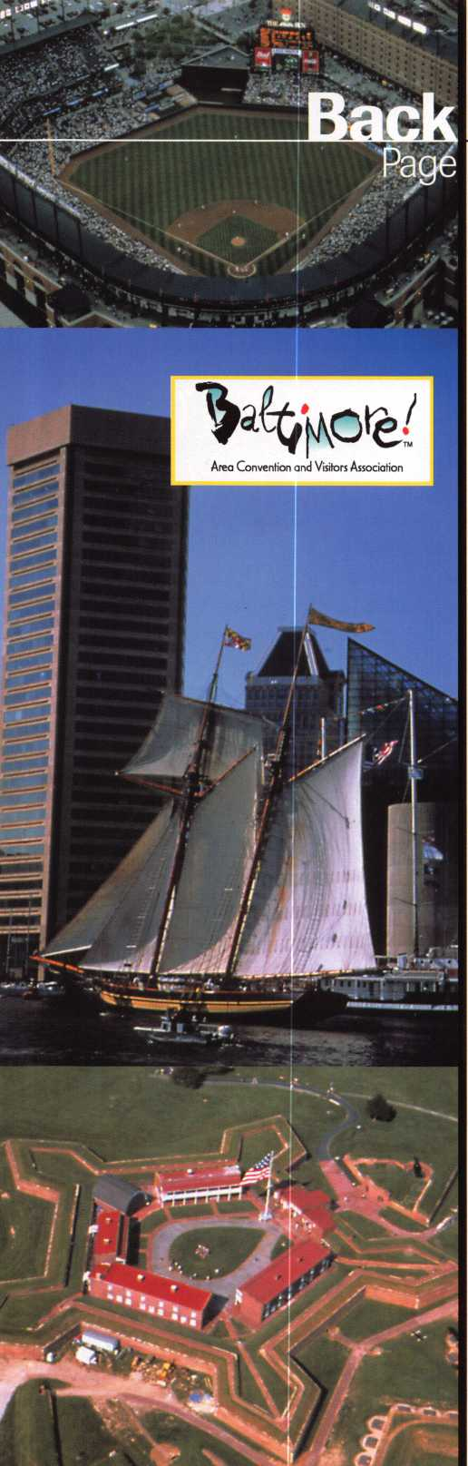

Past and the Future

Discover the history of Baltimore while attending ALOA 2001

ALOA 2001 will be held at the Baltimore Convention Center, July  
15-22, 2001, in Baltimore Maryland, the perfect city to learn about  
new products, new technology and a part of American History.

Another aspect of a town as old and new as Baltimore is the fine  
cuisine. You can get the latest and greatest from old Baltimore  
eateries famous for their amazing seafood. Take for example the  
famed Phillips Seafood Restaurant in Baltimore. The Phillips family  
has been serving fresh seafood and regional fare to the Mid-Atlantic  
Region for more than 40 years. Known for their Maryland style crab  
cakes and Chesapeake Bay seafood, Phillips’ dedication to quality  
value and friendly serivce has been their top priority.

Can you answer the following fishy questions for a Phillips-related prize?

1. Crab cakes are best served:
2. At a little girl’s birthday party with balloons and ice cream.
3. Cold — right out of the fridge — with your football buddies  
   on Monday night.
4. For Valentine’s Day with your one and only.
5. What’s the difference between regular Clam Chowder and Boston  
   Clam Chowder?
6. About three bucks per bowl, if you don’t watch out.
7. One’s pronounced “Chudda” and the other’s pronounced  
   “Chowda.”
8. While one is a delightful and appetizing soup, the other is a  
   local slang term referring to footsoak.
9. In days of old, condemned pirates would sometimes hang for  
   weeks on end on the docks overlooking the harbor, so that  
   everyone passing through the port would know the dangers of  
   pirating. But that’s not done anymore. What’s more likely to be  
   found hanging on a hook in Baltimore Harbor today?
10. Raven’s Quarterback Tent Dilfer
11. A 400-pound marlin
12. An old shoe

Send in your answers for a chance at a prize to:

Baltimore Seafood Trivia  
do Keynotes  
3003 Live Oak Street  
Dallas, TX 75204  
214/827-1810 fax  
[editor@aloa.org](mailto:editor@aloa.org)

Plan now to attend ALOA 2001 in Baltimore and see the many  
great things this city has to offer.



WITH IT.

BEFORE ANYONE ELSE FINDS OUT, LOOK INTO SAFETECH 2001

When professionals don't keep up with the evolution of their industry it shows.

It shows in loss of business, of revenue, of customer confidence.

Focus on where your professional future is going at SAFETECH 2001 in St. Louis, Missouri.

In a city that fires the imagination, you will discover safe technology advances you never imagined possible.  
For more information call 214.827,7233, or email [convention@savta.org](mailto:convention@savta.org).

SAFETECH 2001—A Safe Odyssey.

SAFETECH

2001

A SAFE ODYSSEY

ST. LOUIS, MO APRIL 30-MAY 5

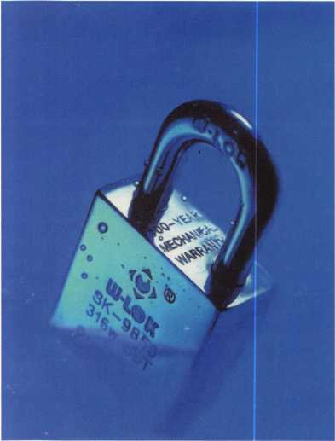

* 100% Stainless Steel
* 100 Year Mechanical Warranty
* Specially Hardened Cylinders
* Patent Controlled Keying
* Resistant to Environmental Conditions

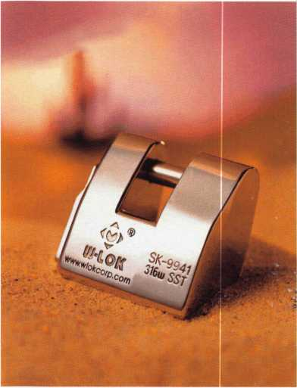

**UJ-LOK**

Stainless Steel  
Security Solutions

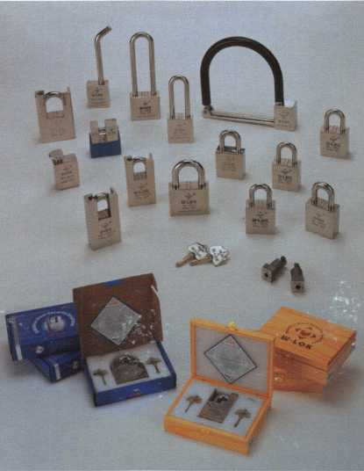

W-LOK Corporation 861 Praductians Place Hailand, Ml 49423

Toll Free: 8I7.355.WL0K Fax: 816.3554295

Web: [www.wlokcorp.com](http://www.wlokcorp.com)

Email: [office@wlokcorp.com](mailto:office@wlokcorp.com)

*a*

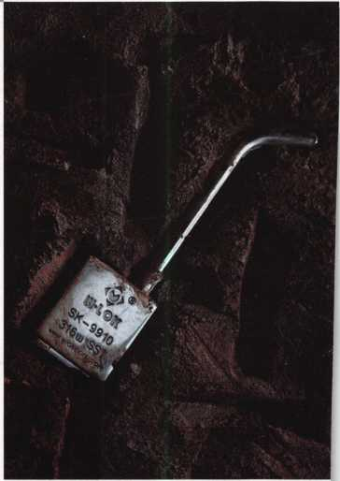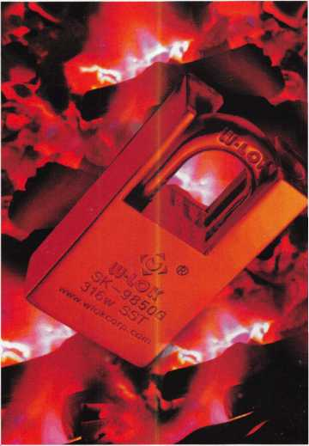

* Dealerships Available
* Representative Opportunities
* Custom Designs
* OEM Capabilities
* Internet Partnerships